Gardens of the Future
Student Material

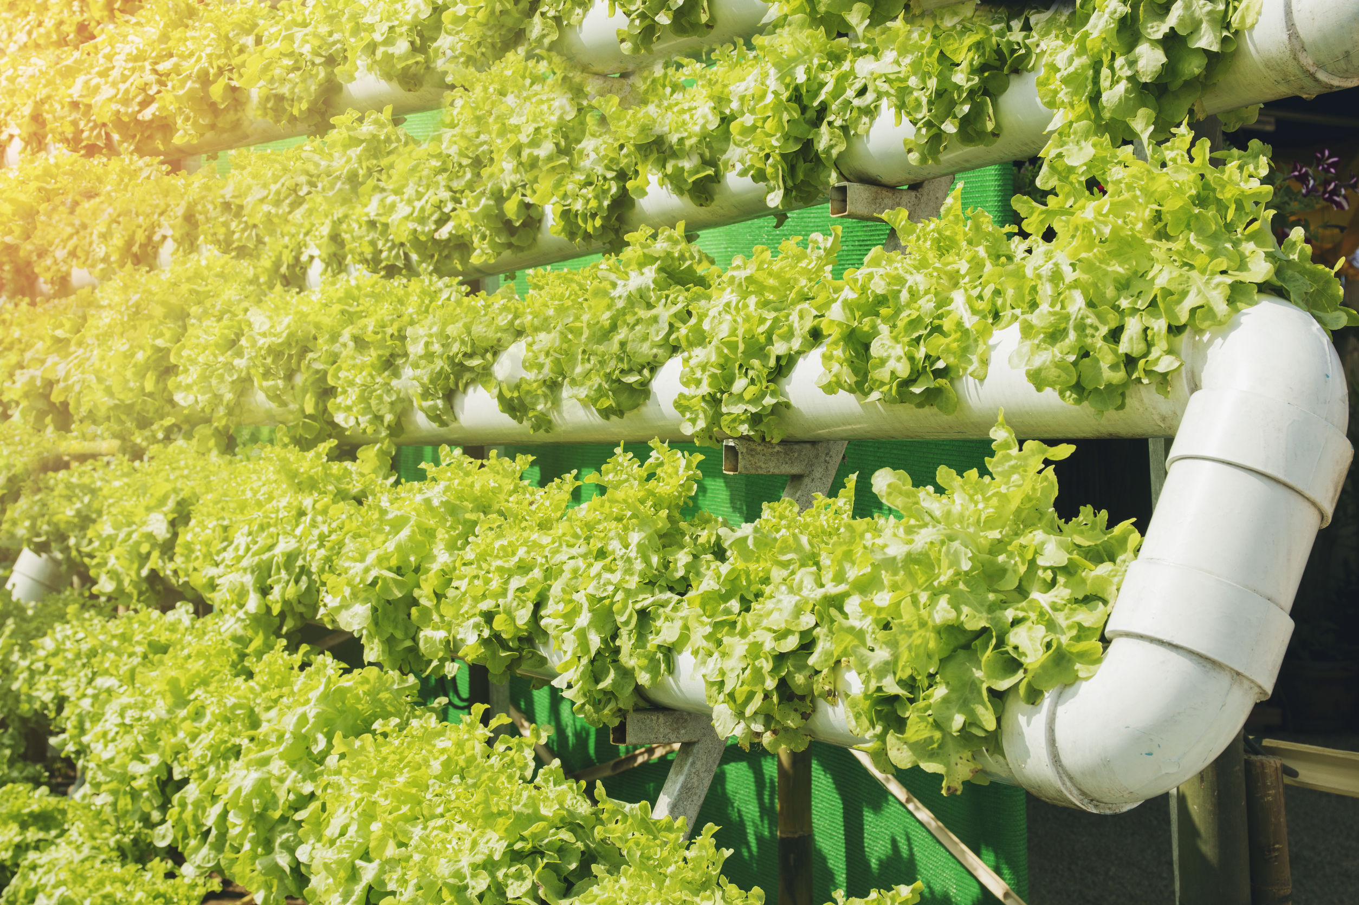
More than 820 million people worldwide do not have enough food to eat. Although hunger affects all regions of the world, it is most prevalent in Africa and Asia. Sub-Saharan Africa has the highest prevalence of hunger in the world. About 25 percent of the population doesn’t have enough food to eat compared to 9 percent of the total world population.

According to the World Hunger Education Service, several factors contribute to persistent hunger. For example, many people suffering from hunger in Africa don’t have enough money to purchase food. Additionally, wars between countries can disrupt imports and exports. At times, land and equipment used to produce food are damaged by war.

In some cases, the environment plays a role in a region’s ability to sustain crops. The quality of the soil may not support plant growth. In urban areas, there may not be enough green space to grow food. You may have been taught that plants need sun, soil, and water to survive, but that’s not exactly true.

Have you ever heard of hydroponics? It’s a way of growing plants without soil! How is that even possible? Scientists, researchers, and entrepreneurs are exploring how hydroponics, aquaponics, and vertical gardening could be used to reduce world hunger.

Of course, some say it cannot be done. Some farmers are against the hydroponic movement because synthesized nutrients are used in the water. Is providing food for the world’s hungry citizens worth the possible effects of the chemical nutrients?

World hunger impacts you as a member of our global society, no matter where you live or how much you have to eat. How is your community affected by hunger? What about your country or region of the world? How does a community experiencing hunger halfway around the world influence your life?

You can make a positive impact on the lives of others by designing a plan to provide a sustainable food source for one hungry community. What can you do to eliminate world hunger? Decide who should see your solution and write a proposal to advocate for those in need!

Gardens of the Future Rubric (Individual Design Journal)
Student Material
 | Novice | Apprentice | Practitioner | Expert
Formulate | includes:  - identification of communities with food shortages | includes:  - description of communities with food shortages  - description of impact of food shortage in one area on other areas of globe | includes:  - comparison of communities with food shortages to those without food shortages  - explanation of impact of food shortage on global scale (cause-and-effect relationships)  - hypothesis of future events if world hunger is not eliminated | all of Practitioner plus: includes personal connection to world hunger
Explore Plants: Structure and Growth | includes:  - description of one way to grow plants without soil  - identification of two or more structures within a plant cell  - identification of one environmental factor that impacts growth  - illustration of life cycle of plant | includes:  - description of two ways to grow plants without soil and explanation for how it is possible  - description of two or more structures within a plant cell  - description of two environmental factors that impact growth  - illustration of life cycle of plant and role of plant structures in reproduction | includes:  - description of two ways to grow plants without soil and explanation for how it is possible with data from own experiment  - explanation of how two or more structures within a plant cell support growth  - description of two environmental factors and one genetic factor that impact growth  - illustration of life cycle of plant and role of plant structures and animal behaviors in reproduction | all of Practitioner plus: includes information from one additional credible source not provided by the teacher
Explore Alternate Gardens | includes:  - two or three questions about hydroponics  - two or three facts about hydroponics | includes:  - three or four questions about hydroponics  - three or four facts about hydroponics  - differentiation of hydroponics to aquaponics | includes:  - five or more questions about hydroponics  - five or more facts about hydroponics  - comparison of hydroponics to aquaponics  - analysis of how hydro- or aquaponics could be used as urban agriculture | all of Practitioner plus: includes one additional alternative method of food growth in comparison and analysis
Ideate | includes two possible solutions to end hunger in one community | includes:  - three possible solutions to end hunger in one community  - one possible solution that could be applied in more than one community | includes:  - three possible solutions to end hunger in one community  - two possible solutions that could be applied in more than one community | all of Practitioner plus:  includes one solution that could be applied on global level
Student Material
Gardens of the Future Rubric (Group Solution)

 | Novice | Apprentice | Practitioner | Expert
Sift | includes:  - pros and cons of each group member’s proposed solution  - identification of appropriate audience | includes:  - pros and cons of each group member’s proposed solution  - description of feasibility of each proposed solution  - identification of appropriate audience and description of how they can provide support | includes:  - pros and cons of each group member’s proposed solution  - description of feasibility of each proposed solution  - comparison of unintended consequences of proposed solutions  - explanation of why target audience was selected | all of Practitioner plus: includes explanation of why final solution was chosen
Garden Plan Proposal | includes:  - introduction of alternative garden for community with lack of food  - supporting data from personal experiments  - evidence from research  - relationships between solution and evidence using linking words  - conclusion | includes:  - introduction of alternative garden for community with lack of food  - supporting data from personal experiments  - relevant evidence from research gathered from credible sources  - clear relationships between solution and evidence using linking phrases  - conclusion | includes:  - introduction of alternative garden for community with lack of food  - supporting data and evidence from personal experiments  - logical, relevant evidence from research gathered from credible sources  - clear relationships between solution and evidence using linking phrases and clauses  - conclusion supporting suggested solution | all of Practitioner plus: includes possible counter-arguments against solution and response(s)

Teacher Material
Gardens of the Future Scaffold for Learning
Benchmark Video and Discussions
- Unit launch to create a felt need
- Design Process
- World hunger
- Alternative gardening practices
Instructional Activities: Learning
Instructional Activities: Additional
Instructional Texts/Websites  - Learn parts of a plant cell (I, P)  - Learn basic functions of plant cell organelles (I, P)  - Understand causes and effects of hunger in the Philippines (I, P)  - Understand causes and effects of hunger in Sudan (I, P)  - Learn about hydroponics (I, SG)  - Research a country (I, P, SG)  - Research world hunger (I, P)  - Creating solutions (I, P, SG)  - Writing a proposal (I)  - Cause/effect —Compare/contrast (I, P) | Instructional Videos  - Learn parts of a plant cell (I, P)  - Learn basic functions of plant cell organelles (I, P)  - Understand causes and effects of hunger in the Philippines (I, P)  - Understand causes and effects of hunger in Sudan (I, P)  - Learn about hydroponics (I, SG)  - Research a country (I, P, SG)  - Research world hunger (I, P)  - Creating solutions (I, P, SG)  - Writing a proposal (I)  - Cause/effect — Compare/contrast (I, P) | How-to Sheets  - Identify credible sources  - Conduct an experiment  - Set up a data log  - Take notes  - Cause/effect  - Compare/contrast | Practice  - Label plant cell organelles (I, P)  - Read/analyze text on hunger in Philippines  - and Sudan (I, P, HW)  - Draft one question about hydroponics (I)  - Read/summarize text on hydroponics (I)  - Research world hunger (I, P)  - Identify credible sources (I)
Application
- Set up a data log (I)
- Text analysis: cause and effect, compare (I, P)
- Compare/contrast causes/effects of hunger in Philippines and Sudan (I, P)
- Photograph plant growth in experiment (I)
- Design hunger solutions (I, P, SG)
- Write a garden plan proposal (I)
Interactive Websites  - World Hunger Map (I, P)  - Google Earth (I, P)  - Plant Cell Virtual Tour (I, P)  - Freerice — sustainable goals, geography, countries (I, HW) | Learning Centers  - Categorize: Plant or Animal Cell  - View and Describe Plant Cells (microscope needed)  - Build a Plant Cell  - Lab: Plant Growth With and Without Soil  - Cause-and-Effect Web: Hunger in Sudan and Philippines | Small-Group Mini-Lessons  - Learn parts of a plant cell  - Learn basic functions of plant cell organelles  - Understand causes and effects of hunger in the Philippines  - Understand causes and effects of hunger in Sudan  - Learn about hydroponics  - Research a country  - Research world hunger  - Creating solutions  - Writing a proposal  - Cause/effect, compare/contrast | Assessment  - Self-assess parts pf a plant cell (I)  - Self-assess hydroponics (I)  - Use rubric to peer assess task (P)  - Use rubric to self-assess task (I)
Reflection
In your Efficacy Notebook, reflect:
What are your views on world hunger? How can you continue to make a difference? What surprised you about hydroponics? What are your thoughts about this growing process? (I)
Key: Individual (I), Pairs (P), Small Groups (SG), Activities suitable for Homework (HW), Insights Video (IV)

 | ELA |  |  |  |  |  |  |  |  |  | Science
Student | Identifies credible sources | Describes qualities of credible sources | Takes appropriate notes to support final product | Follows procedures to conduct experiments | Identifies cause(s) of hunger in Sudan | Identifies cause(s) of hunger in the Philippines | Identifies effect(s) of hunger in Sudan | Identifies effect(s) of hunger in the Philippines | Summarizes information of hydroponics | Drafts one question regarding hydroponics based on reading | Differentiates between plant and animal cells | Labels organelles within the plant cell | Identifies basic function(s) of plant organelles | Records data from experiment | Describes structure of plant cell
Gardens of the Future Content Facilitation Grid (Week 1 Sample)
Teacher Material

Gardens of the Future Facilitation Grid
Teacher Material
COMPREHENSION:  Ask questions that ensure students understand content and skills needed to solve the problem. | - What do plants need to survive?  - What are organelles?  - What organelles are in a plant cell?  - What is hydroponics? What is aquaponics?
APPLICATION:  Ask questions that ensure the ability of students to apply learning to new situations. | - How are hydroponics and aquaponics different?  - How are animal cells different from plant cells?  - How does the cell wall affect the structure of a plant?
CONNECTION:  Ask questions that ensure the ability of students to apply learning to their lives. | - Have you or someone you known ever experienced extreme hunger or food insecurity? What was it like?  - How do you see global hunger impacting you and your community?  - How do you use plants to satisfy food needs in your life?
SYNTHESIS:  Ask questions that encourage students to create new information from existing data. | - Why do you think young students are taught that plants need soil to survive? How would you dispel this myth for this population?  - Which alternative method of gardening do you think would be most effective in your community? Why?  - How would plants be different without a cell wall? How would mammals be different with cell walls?
METACOGNITION: Ask questions that prompt students to think about their own thinking process. | - What was the most difficult part of this task?  - How did your group come to consensus as you sifted ideas?  - How would you rate your group’s ability to work together? How could you improve in the future?

Gardens of the Future Transfer Task Student Material

Gardens can grow virtually anywhere on Earth, even at our school! Consider what you’ve learned throughout the course of this unit. Which type of garden would be best for our school? What types of plants would you grow? How could they be used to feed students and families in our school community?

Write a persuasive letter to administration with your suggestion. Be sure to include the following:
- Introduction suggesting one type of garden
- Logical, relevant evidence supporting your suggestion
- Research gathered from at least three credible sources
- Conclusion supporting suggested solution
- Diagram of plant cell
- Explanation of how organelles make food and support growth

Gardens of the Future Teacher Notes Teacher Material

Unit Overview
Hunger is a global problem that affects 9 percent of the world’s population. Although that may not seem like much, it is actually about 820 million people. There are a variety of reasons why a particular region may not have enough food to feed its people. In this authentic learning unit, students explore the causes and effects of hunger and use the IDE Corp. Design Process to create a solution using an alternative farming method.
Enduring Understandings | Essential Questions
- We are a small part of a global community. What happens in one area of the world can have an impact on other regions.  - Plant cells and animals are different, and each has specific attributes related to the structure and growth of the organism.  - There are alternative farming/gardening practices that can be employed based on the needs and limitations of a region or community. | - What do plants need to grow and survive?  - What processes occur within a plant cell that support food production and growth?  - What are the strengths and limitations of various alternative farming/gardening methods?
Common Core State Standards Addressed
CCSS.ELA-LITERACY.RI.5.1; CCSS.ELA-LITERACY.RI.5.2;
CCSS.ELA-LITERACY.RI.5.3; CCSS.ELA-LITERACY.RI.5.5;
CCSS.ELA-LITERACY.RI.5.7; CCSS.ELA-LITERACY.RI.5.8;
CCSS.ELA-LITERACY.RI.5.9

CCSS.ELA-LITERACY.W.5.1; CCSS.ELA-LITERACY.W.5.4;
CCSS.ELA-LITERACY.W.5.7; CCSS.ELA-LITERACY.W.5.8;
CCSS.ELA-LITERACY.W.5.9

CCSS.ELA-LITERACY.RI.6.1; CCSS.ELA-LITERACY.RI.6.2;
CCSS.ELA-LITERACY.RI.6.7; CCSS.ELA-LITERACY.RI.6.9

CCSS.ELA-LITERACY.RST.6-8.1; CCSS.ELA-LITERACY.RST.6-8.2;
CCSS.ELA-LITERACY.RST.6-8.3; CCSS.ELA-LITERACY.RST.6-8.4;
CCSS.ELA-LITERACY.RST.6-8.7; CCSS.ELA-LITERACY.RST.6-8.8;
CCSS.ELA-LITERACY.RST.6-8.9

CCSS.ELA-LITERACY.WHST.6-8.1; CCSS.ELA-LITERACY.WHST.6-8.4;
CCSS.ELA-LITERACY.WHST.6-8.7; CCSS.ELA-LITERACY.WHST.6-8.9

Other National Standards Addressed
5-LS1-1; MS-LS1-1; MS-LS1-2; MS-LS1-4; MS-LS1-5; MS-LS1-6; MS-LS1-7

NSS-C.5-8.4; NSS-EC.5-8.1

21st Century Skills Addressed
Core Content and Interdisciplinary Themes  - Subject-Area Mastery  - Global Awareness  - Environmental Literacy | Information and Media Literacy  - Information Literacy  - Media Literacy  - Information and Communication Technology
Learning and Innovation  - Critical Thinking and Problem Solving  - Creativity and Innovation  - Communication and Collaboration | Life and Career  - Flexibility and Adaptability  - Initiative and Self-Direction  - Social and Cross-Cultural Skills  - Productivity and Accountability  - Leadership and Responsibility

