Artistic Persuasion
Student Material


Throughout our lives, we experience moments and relationships that shape who we are. As we grow, we begin to connect with ideas and issues larger than ourselves, including questions of justice, identity, and the planet we share. What inspires you? How do you want to make a positive impact on the world?
Artists have long used their voices, brushes, cameras, and now algorithms to challenge injustice and spark change. Edvard Munch captured the pain of anxiety in The Scream. Diego Rivera’s murals made art accessible to all and celebrated the dignity of working people. Frida Kahlo explored themes of identity, gender, and resilience. Ai Weiwei and the Guerrilla Girls confront political oppression and inequality through their art, while Ansel Adams revealed the beauty of America’s landscapes and inspired the conservation movement.
Today, activist artists such as Eric Almanza, Kehinde Wiley, Banksy, and JR continue to amplify unheard voices. Their work encourages conversation, reflection, and change. With digital tools and artificial intelligence, a new generation of artists is discovering fresh ways to raise awareness and inspire action.
What environmental, social, or political issue moves you most? Which artist’s voice, past or present, resonates with your own? Explore the artistic community across time and technology. Then, design an advocacy campaign that uses art—traditional, digital, or AI-assisted—to inspire others to care and take action.
As Salvador Dalí said, “A true artist is not one who is inspired but inspires others.”

Artistic Persuasion Rubric
Student Material

 | Novice | Apprentice | Practitioner | Expert
Research Journal:  Cause Identification | - describes issue/cause as social, political, and/or environmental  - describes current impact of issue  - describes ideal situation | - describes issue/cause as social, political, and/or environmental  - describes current impact of issue  - hypothesizes possible future impact if left unsolved  - describes ideal situation | - describes issue/cause as social, political, and/or environmental  - describes current impact of issue  - hypothesizes possible future impact if left unsolved  - describes and empathizes with those immediately impacted by issue  - describes ideal situation | all of Practitioner plus: describes personal experience with issue/cause or why it was selected
Research Journal: Cause Analysis | includes:  - list of artists (any medium) who support or advocate for the cause/issue  - identification of counterclaim(s)  - identification of potential impetus for issue/cause  - timeline of 5 or more major events associated with cause/issue | includes:  - list of artists (any medium) who support or advocate for the cause/issue  - description of counterclaim(s) (i.e., who is actively working against the issue/cause and why)  - description of potential impetus for issue/cause  - timeline of 10 or more major events associated with cause/issue | includes:  - list of artists (any medium) who support or advocate for the cause/issue  - analysis of counterclaim(s) (i.e., who is actively working against the issue/cause and why)  - description of potential impetus for issue/cause  - timeline of 10 or more major events associated with cause/issue  - cause and effect web for at least 5 events on timeline | all of Practitioner plus: explanation of technical words or phrases used by those speaking about the issue/cause

Research Journal: Cause Advocacy | includes:  - synthesis of information from 3 or more reliable resources  - explanation of point of view and purpose of each resource  - explanation of text structures and impact on overall readability for one resource  - explanation of the effectiveness of rhetoric for one resource | includes:  - synthesis of information from 4 or more reliable resources  - explanation of point of view and purpose of each resource  - explanation of text structures and impact on overall readability for 2 or more resources  - explanation of the effectiveness of rhetoric for 2 or more resources | includes:  - synthesis of information related to issue/cause from 5 or more reliable resources  - explanation of point of view of the author(s) and purpose of each resource  - comparison of text structures and impact on overall readability for 3 or more resources  - comparison of the effectiveness of rhetoric for 3 or more resources | all of Practitioner plus: calls attention to inconsistencies among resources; identifies resources used to verify accuracy of others
Research Journal: Artists | - identifies one artist who advocated for identified issue/cause  - synthesis of information from 3 or more reliable resources for the artist  - includes one piece of artwork from the artist related to the issue/cause  - includes 3-paragraph biography of the artist | - identifies one contemporary or one historical artist who advocated for identified issue/cause  - synthesis of information from 3 or more reliable resources for the artist  - includes 2 or pieces of artwork from the artist related to the issue/cause  - includes 3- to 5-paragraph biography of the artist highlighting his/her involvement with the issues/cause | - identifies one contemporary and one historical artist who advocated for identified issue/cause  - synthesis of information from 3 or more reliable resources for each artist  - includes multiple pieces artwork for each artist related to the issue/cause  - includes 3- to 5-paragraph biography of each artist highlighting his/her involvement with the issues/cause | all of Practitioner plus: includes information for a third artist who used a medium differing from the other artists
Student Material
Social Media Advocacy | includes:  - series of 5 or more posts  - personal connection to issue/cause  - inspirational pieces of artwork  - goal of social media advocacy project  - integration of 2 or more items from each section of research described in the research journal sections of the rubric | includes:  - series of 8 or more posts  - personal connection to issue/cause  - artists’ connections to issue/cause  - inspirational pieces of artwork and explanations for why each was chosen for advocacy project  - goal of social media advocacy project  - integration of 2 or more items from each section of research described in the research journal sections of the rubric | includes:  - series of 10 or more context and audience appropriate posts  - personal connection to issue/cause  - artists’ connections to issue/cause  - inspirational pieces of artwork and explanations for why each was chosen for advocacy project  - goal of social media advocacy project  - integration of 3 or more items from each section of research described in the research journal sections of the rubric | all of Practitioner plus: includes personal artwork related to issue/cause
Student Material

Teacher Material
Artistic Persuasion Scaffold for Learning
Benchmark Video and Discussions
- Ethics of AI in Art
- Logos, Ethos, and Pathos
Instructional Activities: Learning
Instructional Activities: Additional
Instructional Texts  - Art as a Form of Activism  - The Power of Public Art  - How Artists Use Symbolism to Convey Meaning (HW)  - AI and the Future of Creativity | Instructional Videos  - Write an objective summary  - Code text for central idea development  - Understand point-of-view in informational text (HW)  - Understand rhetorical devices  - Analyze a Work of Art (IV) | How-to Sheets  - Identify a reliable source  - Write an objective summary  - Code text for central idea development  - Create AI-Generated Visuals  - Design an Advocacy Campaign | Practice  - Feedback and Revision Workshop (P)  - Compare and contrast point of view: Literature v. informational text (I, P)  - Describe effectiveness of rhetorical devices (HW)
Application
- Evaluate effectiveness of rhetorical devices (I)
- Design an Advocacy Concept Board (SG)
Interactive Websites  - Google Arts and Culture  - Smithsonian Learning Lab  - Art21.org  - Deep Dream Generator | Learning Centers  - Code text to trace development of central idea(s)  - Categorize: Author’s purpose  - Categorize: Point of view, claim, reason, evidence  - Categorize: Logos, ethos, and pathos | Small-Group Mini-Lessons  - Write an objective summary  - Identify rhetorical devices  - Connect context with point of view  - Choosing a Cause | Assessment  - Rubric Self-Assessment (I)  - Critiques of Artwork (P)  - Artist Reflection and Rationale (P)
Reflection
- What was challenging about this unit?
- How did you grow as an artist and advocate through this unit?
Key: Individual (I), Pairs (P), Small Groups (SG), Activities suitable for homework (HW), Insights Video (IV)
Artistic Persuasion Content Facilitation Grid (Sample)
Teacher Material
Student | Identifies reliable sources of information | Codes text for words related to central idea | Codes text for phrases related to central idea | Codes text for images related to central idea | Integrates coded information to describe central idea of text | Identifies context of informational text | Identifies intended audience of informational text | Describes how context and intended audience influence point of view | Describes logos | Identifies logos in use | Describes ethos | Identifies ethos in use | Describes pathos | Identifies pathos in use | Describes effectiveness of rhetorical devices

Artistic Persuasion Facilitation Questions
Teacher Material

COMPREHENSION:  Ask questions that ensure students understand content and skills needed to solve the problem. | - What are rhetorical devices?  - What are the characteristics of a reliable resource?  - What is the context of this informational piece?  - Who is the author’s intended audience?  - What is the purpose of this text?
APPLICATION:  Ask questions that ensure the ability of students to apply learning to new situations. | - How does the context of a piece and the intended audience influence how the author writes?  - How are opinion and informational pieces the same? How are they different?  - Which statements from the text best support your purpose in advocating for this issue/cause?
CONNECTION:  Ask questions that ensure the ability of students to apply learning to their lives. | - Why did you choose this issue/cause?  - How did the artwork you chose impact you as an individual?  - How can you use rhetoric to enhance your argument?
SYNTHESIS:  Ask questions that encourage students to create new information from existing data. | - How would the author’s writing be affected with the addition or omission of rhetoric?  - How are the contexts of those supporting an issue/cause the same as the contexts of those dissenting of the issue/cause? How are they different?  - What is your interpretation of the Salvador Dali quote in the task statement? How does it apply to the artwork you selected?
METACOGNITION: Ask questions that prompt students to think about their own thinking process. | - How does the artwork you chose represent the issue/cause?  - What process did you use to select your issue/cause?  - How could you use rhetorical devices to enhance your social media campaign?  - Which rhetorical device appeals most to you? Why do you think that is?

Artistic Persuasion Transfer Task

What do these pieces of artwork have in common?
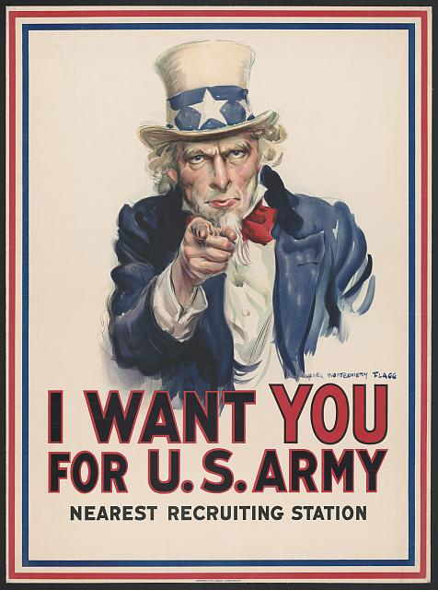
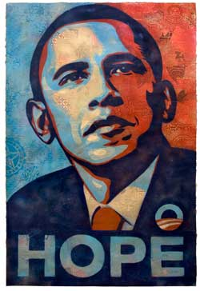
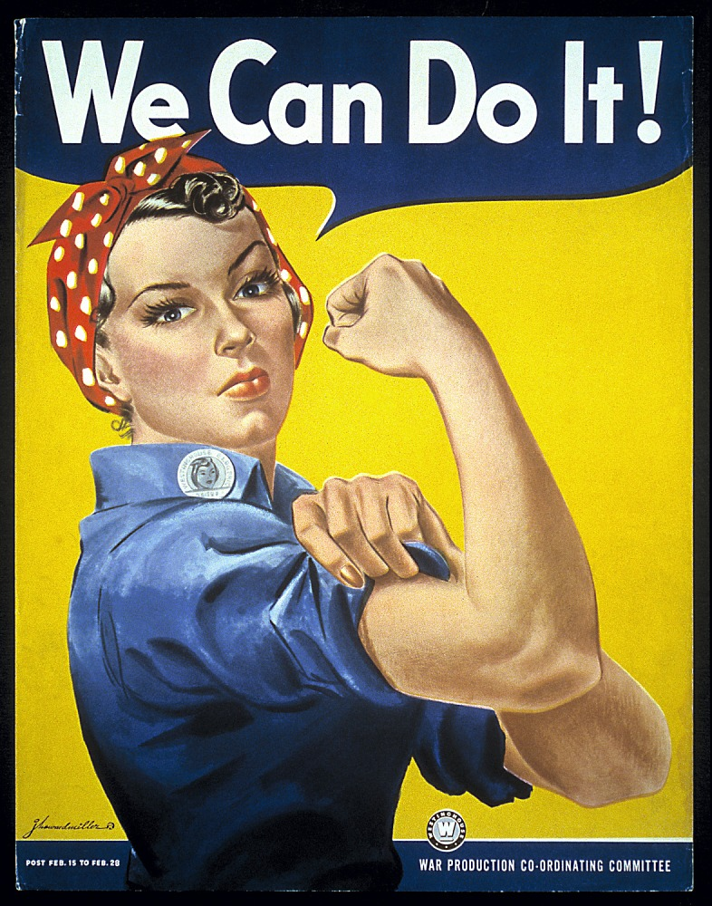

Each of these pieces was created to inspire Americans to act a certain way. Select one of these pieces or another with which you are familiar. Then, research the artist and the artwork. Describe the context of the art and the point of view of the artist and/or organization the artist supported. Finally, create a social media post in which you do the following:

- Explain why you chose to post about the selected piece of artwork.
- Explain the artist’s connection to the issue/cause the artwork supports.
- Describe how context influenced the artist.
- Describe the type of rhetoric (verbal and nonverbal, if applicable) used to persuade the consumer of the artwork.

Artistic Persuasion Teacher Notes
Unit Overview
Persuasive writing isn’t the only way to convince someone to support an issue or cause. Artists use their talents to persuade others through murals, sculptures, paintings, photographs, and more. In this Authentic Learning Unit, students will explore an issue or cause which they would like to support. They will find contemporary and/or historic art pieces aligned with their passion and research the artists who created them while considering the roles of context and point of view in one’s perspective. Finally, students advocate for their selected issue/cause by creating a social media campaign consisting of selected artwork and the students’ synthesis of information about the issue/cause.
Enduring Understandings | Essential Questions
- Art is a powerful medium that can inspire and persuade people to take action for a cause.  - Context and perspective influence the works of writers and artists.  - Writers use rhetorical devices to attempt to convince readers of a way of thinking. | - Which issues and/or causes inspire you to inspire others?  - How can you use social media to spread awareness around an issue or cause?  - How does context affect the point of view and perspective of an author or artist?  - How do your lived experiences impact your perspective on societal, political, and environmental issues?
Common Core State Standards Addressed
CCSS.ELA-LITERACY.RI.11-12.1; CCSS.ELA-LITERACY.RI.11-12.2;
CCSS.ELA-LITERACY.RI.11-12.5; CCSS.ELA-LITERACY.RI.11-12.6;
CCSS.ELA-LITERACY.RI.11-12.7
CCSS.ELA-LITERACY.W.11-12.1a; CCSS.ELA-LITERACY.W.11-12.1b;
CCSS.ELA-LITERACY.W.11-12.4; CCSS.ELA-LITERACY.W.11-12.6;
CCSS.ELA-LITERACY.W.11-12.7; CCSS.ELA-LITERACY.W.11-12.8
21st Century Skills Addressed
Core Content and Interdisciplinary Themes  - Subject-Area Mastery  - Global Awareness  - Civic Literacy  - Environmental Literacy |  | Information and Media Literacy  - Information Literacy  - Media Literacy  - Information and Communication Technology
Learning and Innovation  - Critical Thinking and Problem Solving  - Creativity and Innovation  - Communication and Collaboration |  | Life and Career  - Flexibility and Adaptability  - Initiative and Self-Direction  - Social and Cross-Cultural Skills  - Productivity and Accountability

