Equitable Education for All! Student Material
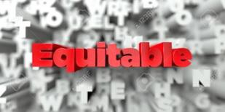
How do you feel about coming to school every day? Do you ever complain about it? Wish you could skip? What if you weren’t allowed to go to school?
Many parents in developing countries struggle to send their children to school. Although school is free, the supplies and clothes needed to attend are too expensive for a “villager’s” income. If a family has more than one child, they must decide which one gets to go to school.

Fathers often choose to send a son to school instead of a daughter. It is believed that boys will earn a better income if they are educated. Girls, on the other hand, make more money for the family if they stay home by raking in the fields, taking care of other children, or working in factories. If they get to go to school, girls usually must leave before they become a teenager. (So, if you lived in a developing country, would you be going to a one-room school or staying home?)

This loss of formal education crushes a child’s potential and allows the poverty cycle to continue. It leaves a child destined to live a confined village life. This inequity must stop. But what can we do?

The United Nations’ Sustainable Development Goal #4 Quality Education shared that, “For two years, starting in mid-2017, more than 9,200 schools closed across eight African countries due to rising insecurity, leaving 1.9 million children without education.”

Awareness needs to be raised about high-quality education so that all children have the same learning opportunities! You can help!

By researching Least Developed Countries (LDCs), you will observe the challenges that school systems in these places are facing and design a better education plan. You will also identify an organization that is supporting this work. You will transfer this information to a Mind Map that you will use for talking points when you start to “campaign” for this cause!

With your Mind Map in hand, you will be armed to inform and convince others to take action! Who can you get to join this movement to provide equitable education for all?

Equitable Education for All Rubric Student Material

 | Novice | Apprentice | Practitioner | Expert
Research  (3 countries) | each index card contains:  - name of country researched  - author’s claim  - evidence of claim  - source cited  includes 1 of the following:  - author’s position or point of view on topic  - identify text structure used  - identify and explain a specific word choice or tone that impacted the piece | each index card contains:  - name of country researched  - author’s claim  - evidence of claim  - source cited  includes 2 of the following:  - author’s position or point of view on topic  - identify text structure used  - identify and explain a specific word choice or tone that impacted the piece | each index card contains:  - name of country researched  - author’s claim  - evidence of claim  - author’s position or point of view on topic  - text structure used  - identify and explain a specific word choice or tone that impacted the piece  - source(s) cited | all of Practitioner plus:  - instead of an index card, work is hyperlinked on Mind Map  plus 1 of the following:  - makes inferences from piece  - explains how author’s position is distinguished (known)  - student explains how s/he was influenced by this piece
Mind Map  Country Strands  (3) | - country researched is named on strand  - each strand contains 2–3 “sub-strands”  - each “sub-strand” contains a word description about the country’s education  system | - country researched is named on strand  - each strand contains 2–3 “sub-strands”  - each “sub-strand” contains a description phrase about the country’s education system | - country researched is named on strand  - each strand contains 3 “sub- strands”  - each “sub-strand” contains a sentence description about the country’s education system | all of Practitioner plus:  - explain why each “description sentence” matters to you and hyperlink it to the Mind Map

Mind Map  Better Way Strand | - name your strand idea  - include 2–3 “sub-strands”  - label each “sub-strand” with a phrase that explains your idea | - name your strand idea  - include 3 “sub-strands”  - label each “sub-strand” with a sentence explaining your idea | - name your strand idea  - include 3 “sub-strands”  - label each “sub-strand” with a  complex sentence: “My idea of  is important because  .” | all of Practitioner plus:  - on a separate document, provide more details on your idea and hyperlink it to this strand
Mind Map  Supportive Organization Strand | - organization’s name on the strand  - include 1 of the following “sub- strands”:  - why this organization is important  - one thing it does to help education  - how to access the organization (a website) | - organization’s name on the strand  - include 2 of the following “sub-strands”:  - why this organization is important  - one thing it does to help education  - how to access the organization (a website) | - organization’s name is on the strand  - include 3 “sub-strands”:  - why this organization is important  - one thing it does to help education  - how to access the organization (a website)  - a paragraph explaining about this organization; can be hyperlinked or placed on another sheet | all of Practitioner plus:  - explain why you chose that organization
Spelling and Punctuation | periods and capital letters are used correctly | spelling, periods, capital letters, and commas are used correctly | - spelling, periods, capital letters, and commas are used correctly  - sentence structure is correct | all of Practitioner plus:  - colons and semicolons are correctly used to cite sources

Presentation | - present your idea to 3 people  - make a list of the 3 people to whom you presented | - present to 3 people  - a completed feedback form is turned in for each person | - present to 3 people  - a completed feedback form is turned in for each person  - each person agrees to 1 of the following:  - post Mind Map on social media  - donate to the foundation you researched | all of Practitioner plus:  - create a 1- to 2- minute video explaining your idea/Mind Map and share it on social media

Equitable Education for All Scaffold for Learning Teacher Material
Benchmark Video and Discussions
- Launch videos: Choose Part I or Part II
- Explain prerequisite tasks: UNSG — Poster Pack, Synthesis Page, Venn Diagram
- Mind Mapping practice
- Using credible sources
Instructional Activities: Learning
Instructional Activities: Additional
Instructional Texts/Websites  - Text structures (I, P)  - Claim and evidence (I, P, SG)  - Point of view (I, P)  - Figurative language (I, P, SG)  - Connotation  - Tone (I, P)  - Citing sources (I, P) | Instructional Videos  - Text structures (I, P)  - Claim and evidence (I, P, SG)  - Point of view (I, P)  - Figurative language (I, P, SG)  - Connotation  - Tone (I, P)  - Citing sources (I, P)  - Mind Maps (I, P)  - Optional (chunk this video) World’s Largest Lesson  - Optional: What Adults Can Learn from Kids | How-to Sheets  - How to hyperlink  - Citing sources  - Choosing text structures  - Punctuation tips | Practice  - Identifying claims and evidence (I)  - Point of view (IV)  - Word choice — figurative language, connotation, tone (I)  - Text structures (I)  - Sentence structure (I)
Application
- Synthesis page on research to your own idea (I)
- Venn diagram comparing your research to your own educational experience (I)
- Share your idea with a peer (P)
Interactive Websites  - Freerice (I, HW)  - Explore developing countries and their education systems  (I, HW)  - People to follow: Malala Yousafzai, Muzoon Almellehan, Mohamad Al Jounde (I.P)  - Foundation Ideas: Comic Relief, Red Nose Day, Do Something (I, P) | Learning Centers  - Text Structures (I, P)  - Claim and evidence (I, P)  - Point of view (I, P)  - Figurative language (P, SG)  - Connotation (P, SG)  - Tone (I, P) | Small-Group Mini-Lessons  - Text Structures  - Claim and Evidence  - Point of View  - Figurative Language  - Connotation  - Tone  - Citing Sources | Assessment  - Completed form from presentation (I)  - Peer feedback from Mind Map explanation (P)  - Use rubric to peer edit task (P)  - Use rubric to self-assess task (I)
Reflection (I)
- How did you feel at the end of this task?
- What else might you consider doing for this cause?
- What was easy/challenging for you coming up with a “new idea”?
- What might be another way to “get the word out”?
Key: Individual (I), Pairs (P), Small Groups (SG), Activities suitable for homework (HW), Insights Video (IV)

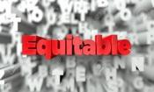
Synthesis Graphic Organizer Teacher Material
Directions: In the boxes on the left, summarize your information from the three LDCs.
Consider the information you recorded. In the box on the right, share what new idea you can develop to make education better for all!

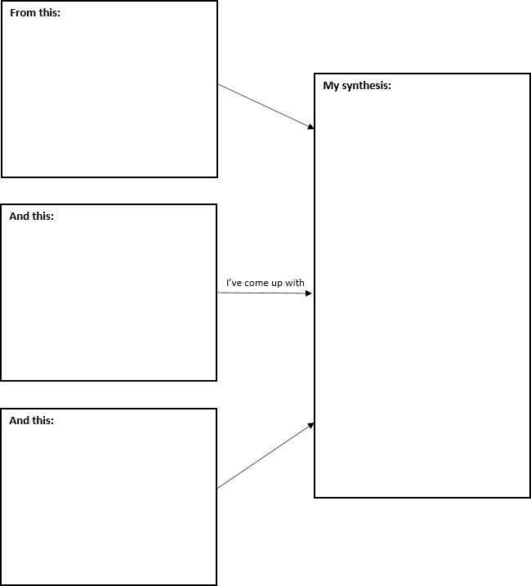

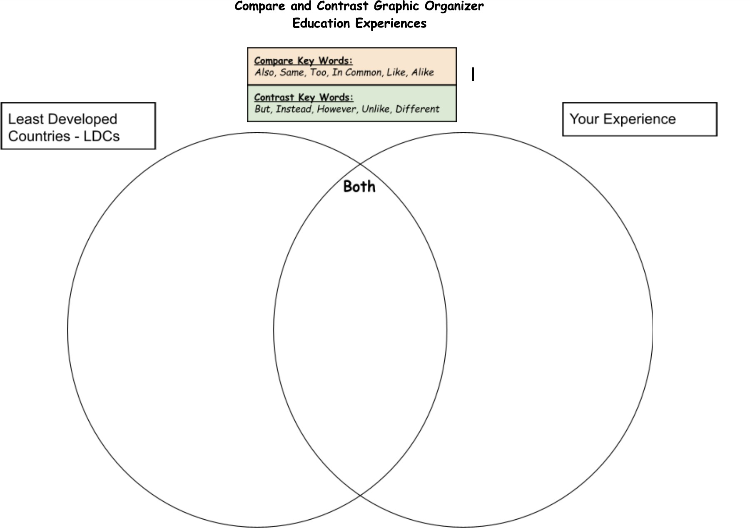
Venn Diagram Comparing Educational Experiences

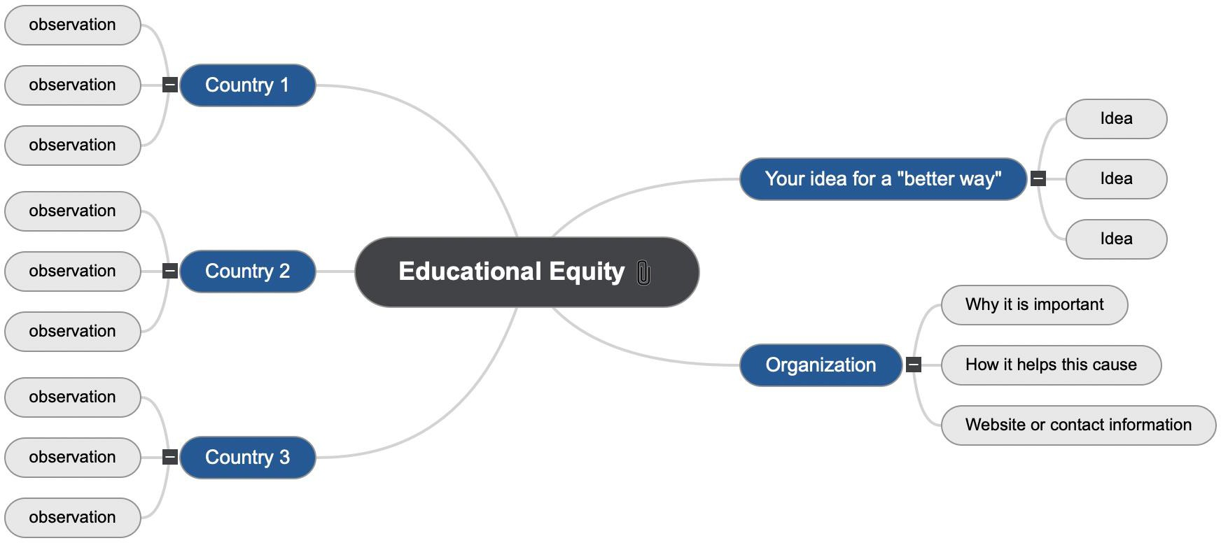
Mind Map — Educational Equity — Sample

Equitable Education for All Facilitation Questions Teacher Material

COMPREHENSION:  Ask questions that ensure students understand content and skills needed to solve the problem. | - Name the text structure for your source.  - What is the claim for your source?  - Show me an example of figurative language, specific word choice, tone, and connotation.  - What concepts are you gathering from your reading?  - What source are you using?
APPLICATION:  Ask questions that ensure the ability of students to apply learning to new situations. | - How do you know that is the structure for your source?  - What evidence supports that claim in the piece?  - How did that impact the article/piece?  - What “aha” moments did you have?  - Why did you choose it?
CONNECTION:  Ask questions that ensure the ability of students to apply learning to their lives. | - Where have you seen that structure used before?  - What are you noticing about other education systems compared to your experience?  - Did that strategy work to convince you? Why or why not?  - How does this differ, or what have you realized about your own educational experiences?  - Have you used this source before?
SYNTHESIS:  Ask questions that encourage students to create new information from existing data. | - How do the structures help you organize your information?  - What are you noticing about the various authors’ points of view?  - What are you noticing about word choice and tone in informational reading?  - What ideas are you getting from this research that will become evident in your “new idea” design?  - How do you determine if it is a reliable source?
METACOGNITION:  Ask questions that prompt students to think about their own thinking process. | - Which structure have you found is easiest for you to follow? Why?  - Which piece of evidence so far is going to impact your “new idea” design?  - What ideas or tips will you take from these authors to use in your piece?  - What have you noticed about how you are choosing which information matters the most and will be used in your Mind Map?  - What matters most to you when determining a creditable source?

Equitable Education for All Content Facilitation Grid (Sample) Teacher Material

Student | Can name text structures | Identifies position of author | Identifies specific word choice in a piece | Identifies tone | Research information is organized | Cites sources | Identifies point of view | Identifies figurative language
M – mastery P – peer tutor level HW – needs homework for reinforcement W – working on it ML – needs a mini-lesson

Equitable Education Transfer Task Student Material
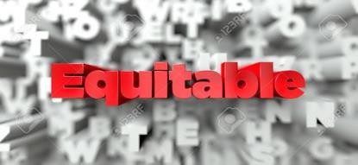

Watch a clip or read a text on inequity.

Respond to the following:

- Identify the author’s claim or message.
- Explain how the claim was supported. Name at least two ways.
- Identify the author’s position/point of view on this topic.
- Explain how you know.
- What new problem or solution can you identify after watching or reading this piece?

Thank you for opening your eyes to a world outside of your own! We need you! ☺

Equitable Education for All Teacher Notes Teacher Material
Unit Overview
The goal of this unit is to create empathy with other children/students around the world and strive to create an awareness of inequity. In this unit, students will develop an understanding of how other children are, or are not, educated around the world. Students will realize that they have the power and the ability to make a change in the world.
Common Core State Standards Addressed
CCSS.ELA LITERACY.RI.7.1
CCSS.ELA-LITERACY.RI.7.2
CCSS.ELA-LITERACY.RI.7.3
CCSS.ELA-LITERACY.RI.7.4
CCSS.ELA-LITERACY.RI.7.5
CCSS.ELA-LITERACY.RI.7.6
CCSS.ELA-LITERACY.RI.7.7
CCSS.ELA-LITERACY.RI.7.8
CCSS.ELA-LITERACY.W.7.7
CCSS.ELA-LITERACY.W.7.8
CCSS.ELA-LITERACY.W.7.9
CCSS.ELA-LITERACY.SL.7.1
CCSS.ELA-LITERACY.SL.7.2
CCSS.ELA-LITERACY.SL.7.3
CCSS.ELA-LITERACY.SL.7.4
CCSS.ELA-LITERACY.SL.7.5

National Standards/Content Addressed
Social Studies
NSS-G.K-12.1
NSS-G.K-12.2
NSS-G.K-12.5

Technology
NT.K-12.1,2,3,4,5,6

Enduring Understandings | Essential Questions
- Discover how other children learn around the world.  - Create empathy for others.  - Use your personal human “superpower” to make a difference.  - Be a role model for others to join in the process.  - The Learner-Active, Technology-Infused Classroom encourages students to take charge of their learning. | - How can you use your voice and “superpower” to improve the lives of others?  - How can we make positive connections with other people around the world?  - Why is it important to make these connections?  - What are the benefits of learning about and from one another?
21st Century Skills Addressed
COMPLETE LIST of 21st Century Skills:

Core Content and Interdisciplinary Themes
- Global Awareness
Learning and Innovation
- Critical Thinking and Problem Solving
- Creativity and Innovation
- Communication and Collaboration
Information and Media Literacy
  - Information Literacy
  - Media Literacy
  - Information and Communication Technology
Life and Career:
  - Initiative and Self-Direction
  - Social and Cross-Cultural Skills
  - Leadership and Responsibility

