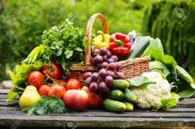
Food for Thought Task Statement Student Material

What did you have for breakfast? What will you eat for dinner? Is someone making you eat your vegetables? Even if you do not like leafy greens, consider yourself lucky!

Every day, one in nine people does not get enough food to eat. Forget three daily meals; many do not even get one.

According to the World Food Programme, one in three people is malnourished. This means that although people may get something to eat, the food lacks vitamins and nutrients, so their bodies can’t function properly.

For example, many children in Guatemala often only eat corn tortillas and salt because it is all they can afford. Can you imagine eating only corn tortillas every single day?

In 2016, the United Nations created 17 Sustainable Development Goals. The UN hopes to accomplish these goals by 2030. Goal number 2 is “Zero Hunger.”

Many companies have joined forces to help support the United Nations with these goals, such as
Freerice.com, an interactive game site. The site has multiple categories of questions that level up with each correct answer. Every time you answer questions correctly, Freerice donates rice to less developed countries. The site is also supporting the UN’s Sustainable Goals by making the 17 Sustainable Goals topic one of their categories! Your contribution will be through multiplication facts. Each correct multiplication answer will help feed others!

We need to spread the word about world hunger and the ways we can fight it. To help do that, choose an “End World Hunger” topic. Then, through your reading and research, come up with ways to educate others
about food waste and world hunger. We need to show people how they can help and why it is so important that they do.

Completing these tasks will help the United Nations attain its goal and put an end to world hunger.

Let’s do what we can to support this cause! Are you ready?!

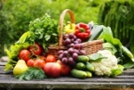
Food for Thought Rubric Student Material
 | Novice | Apprentice | Practitioner | Expert
Nonfiction Research | - identifies World Hunger Focus  synthesis page includes:  - 2 sources  - summarizes text  - identifies text feature from piece | - identifies World Hunger Focus  synthesis page includes:  - 2 sources  - identifies how author made his/her point  - identifies text feature from piece  - understands purpose of text feature | - identifies World Hunger Focus  synthesis page includes:  - 3 sources  - identifies specifically how author made his/her point  - identifies text feature from piece and information the feature gave | all of Practitioner plus:  identifies the type of structure the author used in the piece and why that format worked (or didn’t)
Fiction Research | - reads 1–2 fiction texts  synthesis page includes:  - how the character felt  - author’s message  - names 1–2 specific words or phrases the author used to explain message/create tone  - gleans additional insight from 1 illustration | - reads 3 fiction texts  synthesis page includes:  - how the character felt  - author’s message  - names 1–2 specific words or phrases the author used to explain message/create tone  - gleans additional insight from 1 illustration | - reads 3 fiction texts  synthesis page includes:  - how the character felt  - author’s message  - 3 pieces of evidence that support message  - names 3 specific words or phrases the author used to explain message/create tone  - gleans additional insight from 1 illustration | all of Practitioner plus:  student “connects” with 1 of the characters in the story and writes a dialogue interaction showing empathy for the character/offers a solution to the character’s challenge
Poster | - identifies World Hunger Focus as central point of poster  - includes 3–4 ways people can do their part in fighting world hunger  - includes 2–3 significant visuals  - information is somewhat legible | - identifies World Hunger Focus as central point of poster  - based on some research, includes 3–4 sentences about 3–4 ways people can do their part in fighting world hunger  - each “way” uses a “because” sentence  - includes 2–3 significant visuals  - includes 1–2 domain-specific terms  - information is legible and loosely organized | - identifies World Hunger Focus as central point of poster  - based on research, includes 5 sentences about 5 ways people can do their part in fighting world hunger  - each “way” uses a “because” sentence  - includes 3 significant visuals  - includes 3 domain-specific terms  - information is legible and organized | all of Practitioner plus:  poster provides a website or additional resources for more information on this topic
Group Discussion/  Presentation | - comes to discussion having read material  - speaks clearly  - follows discussion protocol with support  - asks appropriate questions  - stays on topic with support | - comes to discussion prepared with some notes  - expresses ideas clearly  - speaks clearly  - with prompting:  - follows discussion protocol  - stays on topic  - 1 or more of the following:  - asks questions of others to clarify understanding  - contributes comments to topic | - comes to discussion prepared with notes  - expresses ideas clearly  - speaks clearly at an understandable pace  - follows discussion protocol  - determines the main idea of other presentations  - asks questions of others to clarify understanding  - contributes comments to topic  - stays on topic | all of Practitioner plus:  keeps the group on task, includes quiet participants, leads the group in synthesizing information
Freerice Calculations | - has log entries for duration of unit that shows calculations from Freerice earnings  - some calculations are correct | - completes daily log for duration of unit that shows calculations from Freerice earnings  - most calculations are correct | - completes daily log for duration of unit that shows calculations from Freerice earnings  - calculations are correct | all of Practitioner plus:  - helps calculate class earnings  - helps manage class goal chart
Food for Thought Scaffold for Learning Teacher Material
Benchmark Video and Discussions
- Unit launch to create felt need: Is This Fair?/Two types of hunger — starvation/malnutrition
- Survival biscuits*, used in times of famine, eaten 3 times a day
- End World Hunger Topics: Don’t Waste Food, Plant a Garden, Volunteer, Educate Others, Read and
Reflect on Hunger, Brainstorm Solutions, Support a Cause, Start a Donation Jar
*Additional resource suggestions can be found at the end of this unit.
Instructional Activities: Learning
Instructional Activities: Additional
Instructional Texts/Websites  - Complex sentences using because (I, P)  - Note-taking (I)  - Character traits and feelings (I, P)  - Author’s mess./craft/word choice  - Finding supportive evidence (IV)  - Figurative language/tone  - Text features (I, P)  - Analyze illustrations (P, SG)  - Multiplication facts (I)  - Adding/subtracting multiple digits  - Synthesizing information (P, SG) | Instructional Videos  - Complex sentences using because (I, P)  - Note-taking (I)  - Character traits and feelings (I, P)  - Author’s mess./craft/word choice  - Finding supportive evidence (IV)  - Figurative language/tone  - Text features (I, P)  - Analyze illustrations (P, SG)  - Multiplication facts (I)  - Adding/subtracting multiple digits  - Synthesizing information (P, SG) | - How-to Sheets  - Discussion group protocol  - Complex sentences using because  - Create Freerice account  - Multiplication  - Adding/subtracting multiple digits  - Text features  - Supportive evidence  - Figurative language | Practice  - Note-taking: nonfiction/fiction (I)  - Character traits and feelings (I, P)  - Author’s message/craft/word choice (IV)  - Finding supportive evidence (I, P)  - Text features/analyze illustrations  - Multiplication facts  - Add/subtract multiple digits (I, HW)
Application
- Synthesis pages (I)
- Calculations sheet (I)
- Poster/discussion groups (I, P, SG)
- Optional Saveful calculate savings
- Optional Freerice Challenge
Interactive Websites  - Freerice: math facts, sustainable goals, geography  (I, HW)  - World’s Largest Lesson (P, SG)  - Khan Academy (I, HW)  - Optional: calculate savings  - Optional: Freerice Challenge | Learning Centers  - Picture books* for taking notes  (I, P)  - Complex sent. using because (I)  - Author’s message/craft (I, P)  - Finding supportive evidence (I, P)  - Figurative language (I, P, SG)  - Text features (I, P)  - Analyze illustrations (P, SG)  - Multiplication facts (I, P)  - Adding/sub. multiple digits (I, P) | Small-Group Mini-Lessons  - Complex sentences using because  - Note-taking  - Character traits and feelings  - Author’s mess./craft/word choice  - Finding supportive evidence  - Figurative language/tone  - Text features  - Analyze illustrations  - Multiplication facts  - Adding/subtracting multiple digits  - Synthesizing information | Assessment  - Self-assess math facts (I)  - Use rubric to peer edit task (P)  - Use rubric to self-assess task (I)
Reflection
- Watch video: Is This Fair? Then ask:
  - What differences did you notice about Christina and Nindy?
  - How do you think each girl might feel?
  - What are some things every kid needs?
Key: Individual (I), Pairs (P), Small Groups (SG), Activities suitable for Homework (HW), Insights Video (IV)
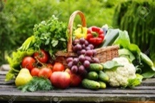
Food for Thought — Sample Calculations Page — Grains of Rice

Date | Started with | Ended with | Amount I earned today (difference)

Food for Thought — Synthesis Page — Informational

Directions: Gather information from text/video and text features. Then create “because” statements. Include how people can do their part to end world hunger and why it is so important that they do.
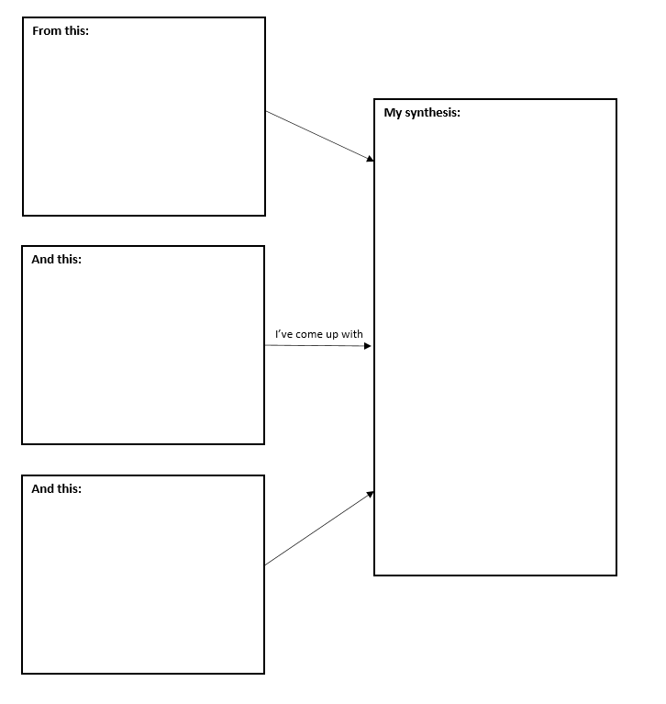

Food for Thought — Synthesis Page — Fiction
Directions: Gather information from stories about how the character feels and the author’s message. Include supporting evidence. Analyze one illustration. Then, synthesize an overall tone from these stories and messages. Include how this made you feel.
Food for Thought Sample Facilitation Questions Teacher Material
COMPREHENSION:  Ask questions that ensure students understand content and skills needed to solve the problem. | - Identify a text feature.  - What are ways an author can emphasize a point (author’s craft)?  - What evidence have you found to support an idea?  - What do you know about multiplication?
APPLICATION:  Ask questions that ensure the ability of students to apply learning to new situations. | - What information does the text feature provide?  - How can an author’s word choice impact a piece?  - How does that prove the author’s point or message?  - Can you multiply these facts _______?
CONNECTION:  Ask questions that ensure the ability of students to apply learning to their lives. | - Where might you encounter a text feature in your life?  - What craft strategy moves you?  - From this evidence, what are you noticing about hunger and poverty?  - When have you needed to multiply outside of our class?
SYNTHESIS:  Ask questions that encourage students to create new information from existing data. | - Why might text features be helpful when reading difficult texts?  - How can an author’s word choice impact informational text?  - How is this evidence formulating your ideas?  - What multiplying strategy do you use?
METACOGNITION:  Ask questions that prompt students to think about their own thinking process. | - Which type of text features do you prefer? Why?  - What strategies or tips can you take away from an author and apply it to your writing?  - How has this evidence impacted you?  - Why does this strategy work best for you?

Food for Thought Sample Facilitation Grid Teacher Material

Student | Names text features | Identifies text features | Identifies specific word choices in a piece | Names craft strategies used by author | Identifies supporting evidence | Multiplies with single digits | Adds with multiple digits | Subtracts with multiple digits | Identifies complex sentences | Writes a complex sentence with because
M – mastery P – peer tutor level HW – needs homework for reinforcement
W – working on it ML – needs a mini-lesson

Food for Thought Transfer Task Student Material

We learned a lot about ourselves and others during this unit. Because of our learning commitment, we were able to make a positive difference in the world! How did this unit empower you?

Create a simple 8.5 x 11 infographic that showcases your learning.

What concepts do you feel were most important in this unit? How did this unit empower you?

Be sure to include the following:
- 5 statements about this unit (importance/empowering)
- Each statement is a complex sentence.
For example: “_________was important because_____.”
- 3 examples of an author’s craft technique
- Underline and label the technique used.
- 1 text feature and how the feature represents your thoughts
- 1 statement on why Goal 2,“Zero Hunger,” is important
***************************************************************************
Math Connection: Complete this multiplication problem:

A = Number of statements you wrote
B = Number of author’s craft examples you used
C = Number of text features you used
D = 2 (for Goal 2)

Problem: A x B x C x D = F _____ x _____ x _____ x _____ = _______

Challenge:
G = Number of students in our class

Problem: F x G = H _____ x _____ = _______

H = A lot of positive actions! Bravo!!

Thank you for your contribution toward attaining Goal 2.
We need people like you to help make the world a better place!

*Additional Resource Suggestions

Survival Biscuit Recipe
Ingredients:
1/2 cup sweetened condensed milk (can substitute 1/3 cup of brown sugar and 1/2 cup of milk)
1 cup wheat flour or soy flour
1/4 cup margarine or shortening
1/4 cup water

Scatter a small amount of cornmeal on a 9-inch x 12-inch cookie sheet. Combine all the ingredients together in a mixing bowl, and pat it out onto your prepared cookie sheet. Bake at 400 degrees for 15 minutes. Allow to cool, then cut into wafers, about 2 inches x 2.5 inches.

Starving people might eat nothing but these biscuits for several days. How do you think your body would feel?

Picture Books
One Grain of Rice: A Mathematical Folktale by Demi
Mama Panya’s Pancakes by Mary and Rich Chamberlin and Julia Cairns
Mama Miti: Wangari Maathai and the Trees of Kenya by Donna Jo Napoli and Kadir Nelson
One Hen: How One Small Loan Made a Big Difference by Katie Smith Milway and Eugenie Fernandes
Seedfolks by Paul Fleischman
Chapter Books
Free Lunch by Rex Ogle
Food Fight: Poets Join the Fight Against Hunger with Poems to Favorite Food edited and illustrated by Michael J. Rosen
Invisible Lines by Mary Amato
What the World Eats by Faith D’Aluisio

Note to Teacher: This unit has a dual focus on fiction and nonfiction reading. If you feel this is too much for your students, simply choose to focus on one area of reading.

Food for Thought Teacher Notes Teacher Material
Unit Overview
Create empathy with other children/students around the world and strive to end world hunger. In this unit, students will be engaged in finding solutions to ending world hunger. Plus, through a felt need, they will learn multiplication facts that will become contributions of rice donations. Students will realize that they do have the power and ability to make a difference in the world.
Common Core State Standards Addressed
CCSS.MATH.CONTENT.3.MD.B.3
CCSS.MATH.CONTENT.3.MD.B.4
CCSS.MATH.CONTENT.3.NBT.A.1
CCSS.MATH.CONTENT.3.NBT.A.2
CCSS.MATH.CONTENT.3.NBT.A.3
CCSS.MATH.CONTENT.3.OA.A.3
CCSS.MATH.CONTENT.3.OA.A.4
CCSS.MATH.CONTENT.3.OA.B.5
CCSS.MATH.CONTENT.3.OA.C.7

CCSS.ELA-LITERACY.RL.3.1
CCSS.ELA-LITERACY.RL.3.2
CCSS.ELA-LITERACY.RL.3.3
CCSS.ELA-LITERACY.RL.3.4
CCSS.ELA-LITERACY.RL.3.5
CCSS.ELA-LITERACY.RL.3.6
CCSS.ELA-LITERACY.RL.3.7
CCSS.ELA-LITERACY.RI.3.1
CCSS.ELA-LITERACY.RI.3.2
CCSS.ELA-LITERACY.RI.3.4
CCSS.ELA-LITERACY.RI.3.5
CCSS.ELA-LITERACY.RI.3.6
CCSS.ELA-LITERACY.RI.3.7
CCSS.ELA-LITERACY.RI.3.9
CCSS.ELA-LITERACY.W.3.1
CCSS.ELA-LITERACY.W.3.2
CCSS.ELA-LITERACY.W.3.4
CCSS.ELA-LITERACY.W.3.7
CCSS.ELA-LITERACY.W.3.8
CCSS.ELA-LITERACY.SL.3.1
CCSS.ELA-LITERACY.SL.3.3
CCSS.ELA-LITERACY.SL.3.4
CCSS.ELA-LITERACY.SL.3.6
National Standards/Content Addressed
Social Studies: NCSS Standards
Enduring Understandings | Essential Questions
- Discover how other children live throughout the world.  - Create empathy for others.  - Recognize that there are things they can do to make a difference.  - Educate others to join and be part of a bigger solution.  - The Learner-Active, Technology-Infused Classroom encourages students to take charge of their learning. | - What can you do to make a difference in the lives of others?  - How can we positively contribute to finding solutions to big problems?  - Why is it important to make the world a better place for everyone?  - What are the benefits of helping others?
21st Century Skills Addressed
Core Content and Interdisciplinary Themes
- Global Awareness
- Health Literacy
Learning and Innovation
- Critical Thinking and Problem Solving
- Creativity and Innovation
- Communication and Collaboration
Information and Media Literacy
- Information Literacy
- Media Literacy
Life and Career
- Initiative and Self-Direction
- Social and Cross-Cultural Skills
- Leadership and Responsibility

