Eat Local and End Hunger! Student Material

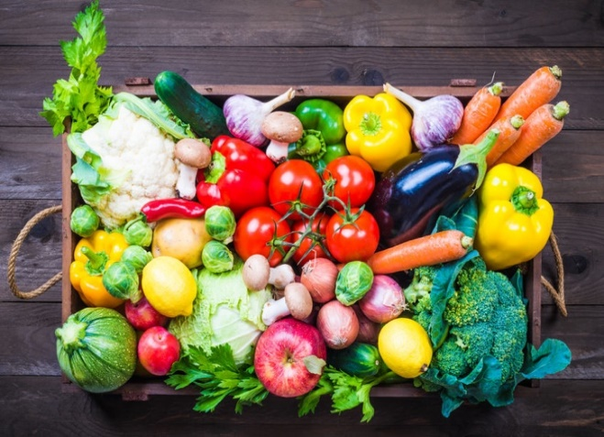
Have you ever thought about where your food comes from? Did you know that according to the United Nations (UN), 2.37 billion people in the world are “without food or unable to eat a healthy balanced diet on a regular basis”? Also concerning is that in 2020, 38.9 million children under the age of 5, or 5.7 percent, were overweight.
In 2015, the United Nations adopted the 17 UN Sustainable Development Goals as an “urgent call to action” to unite the world and provide a “pathway to peace and prosperity” for all people. UN Sustainable Development Goal 2 challenges the world to “end hunger, achieve food security and improve nutrition and sustainable agriculture.”

So, what’s the answer?
A community garden is one way we can help solve these problems! According to GreenleafCommunities.org, community gardens “reduce the impact of food deserts in low-income areas and allow residents greater access to nutritious food that is necessary to live a healthy life.”
You are challenged with planning a space for a community garden that will produce food for those in need. You will need to work collaboratively to decide what type of produce would grow best in your climate. Then, you will need to promote the healthy foods that are available in the community garden with a website!

Working together, we can tackle UN Sustainable Development Goal 2 by creating more access to healthy food. You will help ensure that all people in your community have access to healthier foods!

Eat Local and End Hunger! Rubric Student Material
 |  | Novice | Apprentice | Practitioner | Expert
Garden Journal (Individual) | Design Section | includes:  - accessible space for the garden approved by necessary leaders  includes 1 of the following:  - area and perimeter calculations to fit garden in the space and hold the garden  - research to ensure the produce grown can thrive  - plan for obtaining and using the materials necessary to build the garden | includes 3 of the following:  - accessible space for the garden approved by necessary leaders  - area and perimeter calculations to fit garden in the space and hold the garden  - research to ensure the produce grown can thrive  - plan for obtaining and using the materials necessary to build the garden | includes:  - accessible space for the garden approved by necessary leaders  - area and perimeter calculations to fit garden in the space and hold the garden  - research to ensure the produce grown can thrive  - plan for obtaining and using the materials necessary to build the garden | all of Practitioner plus:  offers advice for additional plants that could grow in the weather zone or advice for other weather zones
Garden Journal (Individual) | Ecosystem Section | includes:  - model of life cycle of 1 plant in our community garden  - model of life cycle of 1 insect in our community garden  - compares 2 life cycles | includes 2 of the following:  - model life cycle of 1 plant in our community garden  - model life cycle of 1 animal in our community garden  - model life cycle of 1 insect in our community garden  includes 1 of the following:  - synthesis of all the life cycles  - explanation of relationship among plants, animals, and decomposers within ecosystem | includes:  - model life cycle of 1 plant in our community garden  - model life cycle of 1 animal in our community garden  - model life cycle of 1 insect in our community garden  - synthesis of all the life cycles  - explanation of relationship among plants, animals, and decomposers within ecosystem | all of Practitioner plus:  model of the garden ecosystem
Garden Journal (Cont.) | Garden Tracking Records | includes:  - diagram of plants with labels  - a few measurements of the growth of plants in data chart using m, cm, and mm  - a how-to sheet on caring for plants during each season  - sign-up method for school community to maintain the garden | includes:  - diagram of plants with labels  - diagram of how the plants take in/produce food  - some measurements of the growth of plants in data chart using m, cm, and mm  includes 2 of the following:  - sign-up method for school community to maintain the garden throughout the year  - designees in charge of each season with contact information  - a how-to sheet on caring for plants during each season | includes:  - diagram of plants with labels for: reproductive structures and  survival structures  - diagram of how the plants take in/produce food  - regular measurements of the growth of plants in data chart using m, cm, and mm to determine how healthy plants are growing  - sign-up method for school community to maintain the garden throughout the year  - designees in charge of each season with contact information  - how-to sheets for caring for each plant during each season | all of Practitioner plus:  criteria in Practitioner column are hyperlinked
Garden Work (Group) | Harvest and Distribution Plan | includes:  - time of each harvest season  - plans for a way food will be stored  - list of where the food needs to be delivered | includes:  - schedule/time of each harvest season  - plans 2 ways food will be stored  - list of where the food needs to be delivered  - outline for who will deliver the food | includes:  - schedule/time of each harvest season  - plans 3 ways food will be stored  - list of where the food needs to be delivered prioritized by need  - plan for who will deliver the food | all of Practitioner plus:  map of where to deliver food
Garden Work (Group) | Promotion of the Garden | website includes:  - recipes that can be made with the produce from garden  - nutritional information about each plant and/or health benefits of each plant | website includes 3 of the following:  - multimedia collection of recipes that can be made with the produce from garden  - nutritional information about each plant  - health benefits of each plant  - information on how to get the produce from the garden  - information on where to get the produce from the garden | website includes:  - multimedia collection of recipes that can be made with the produce from garden  - nutritional information about each plant in the garden with health benefits  - information on how and where to get the produce from the garden | all of Practitioner plus:  opportunities for all community members to continue to add to the collection of information (e.g., recipes, new plants, etc.)
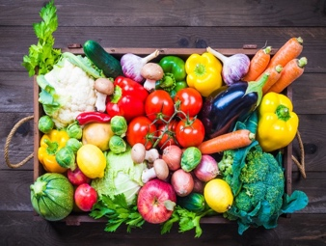
Eat Local and End Hunger! Scaffold for Learning Teacher Material
Benchmark Video and Discussions
- Unit launch: “The World’s Largest Lesson — End Hunger” to create a felt need
- Why are weather zones important?
- What are native plants?
- The benefits of community gardens/life cycles
Instructional Activities: Learning
Instructional Activities: Additional
Instructional Texts/Websites  - Research native plants (I, P)  - Weather/hardiness zones (I)  - Build a garden (I, P, SG)  - Plant spacing (I, P)  - Local gardening concepts (I)  - Nutritious eating (I, P)  - Calculating area and perimeter (I)  - Determine when to use area/  perimeter (P, SG)  - Measuring using the metric system (I, P)  - Recipe writing (IV) | Instructional Videos  - Research native plants (I, P)  - Weather/hardiness zones (I)  - Build a garden (I, P)  - Plant spacing (I, P)  - Local gardening concepts (I)  - Nutritious eating (I, P)  - Calculating area and perimeter (I)  - Determine when to use area/perimeter (P, SG)  - Measuring using the metric system (I, P)  - Recipe writing (IV) | How-to Sheets  - How to build a flower/plant bed  - How to care for the garden  - How to calculate area  - How to calculate perimeter  How to read weather zone maps  - How to draw a life-cycle diagram  - How to write a recipe  - How to measure using the metric system | Practice  - Determine produce type in your weather zone (I)  - Evaluate recipes for produce/health benefits (I)  - Find area and perimeter (I, P)  - Plant in different soils to determine best (IV)  - Plan different ecosystems for your climate (I)
Application
- Purchase produce for garden (I, P)
- Build garden to area/perimeter specs. (I, P)
- Create a schedule have people sign up (I)
- Write “How to Care for” sheets (I, P)
- Evaluate produce growth for each season (I)
- Write healthy recipes for the cookbook that use produce from the garden (I)
Interactive Websites  - NatGeo Kids (I, HW)  - Khan Academy (I, HW)  - Life cycle (I)  - Freerice (I, HW)  - BrainPop — the metric system  (I, P) | Learning Centers  - Native vs. non-native plants (I, P)  - Invasive plants (I, P)  - Is it healthy? (I, P)  - Area and perimeter center (I, P)  - Different soils (I, P)  - Identify parts of plants (SG)  - Match plants and their habitat (I, P) | Small-Group Mini-Lessons  - Research native plants  - Weather/hardiness zones  - Build a garden  - Plant spacing  - Local gardening  - Nutritious eating  - Calculating area and perimeter  - Determine when to use area/perimeter  - Measuring using the metric system  - Recipe writing | Assessment  - Self-assess perimeter and area (I)  - Self-assess measuring with metrics (I)  - Use rubric to peer edit task (P)  - Use rubric to self-assess task (I)
Reflection
Reflect in your journal:
- What would you continue/change in the garden for the following season?
- What did you learn about the community garden that surprised you?
- What was easy/challenging for you? (I)
Key: Individual (I), Pairs (P), Small Groups (SG), Activities suitable for homework (HW), Insights Video (IV)

Eat Local and End Hunger! Facilitation Questions Teacher Material
COMPREHENSION:  Ask questions that ensure students understand content and skills needed to solve the problem. | - What plants will be able to grow in our zone?  - What is the schedule for planting and harvesting?  - How do you determine area and perimeter?  - What soil did you chose?  - What is a habitat?  - What is an ecosystem?  - What is a life cycle?
APPLICATION:  Ask questions that ensure the ability of students to apply learning to new situations. | - How do you plan to distribute the harvest?  - How did finding area and perimeter help you complete this project?  - For what other projects would you use area and perimeter?  - How do you know if an ecosystem is healthy?  - Why are some plants or animals like the ___ not suited for our garden habitat?
CONNECTION:  Ask questions that ensure the ability of students to apply learning to their lives. | - How is this project different from gardening you have done in the past?  - Who were necessary collaborators in this project?  - What is one survival trait a plant has that you wish you could have?
SYNTHESIS:  Ask questions that encourage students to create new information from existing data. | - What advice would you offer to someone starting their own community garden?  - What plants would you recommend to someone in your weather zone?  - How would a severe weather event like a flood/temperature rise of 10 degrees/temperature drop of 10 degrees affect the community garden?
METACOGNITION:  Ask questions that prompt students to think about their own thinking process. | - What changes would you make to the schedules for next year?  - How did you determine the best plants or soil to use?  - How did you work together collaboratively?  - How could you continue to work collaboratively on other projects?

Eat Local and End Hunger! Facilitation Grid Sample Teacher Material
Student | Calculates area | Calculates perimeter | Differentiates between area and perimeter | Explains how area and perimeter impact the other | Accurately measures plants with m, cm, mm | Determines growing zone | Determines appropriate foods to grow | Creates a how-to document to care for the garden | Creates a garden care schedule | Creates a harvest distribution plan | Determines what makes food “healthy” | Creates a harvest schedule | Gathers climate information from maps
M – mastery P – peer tutor level HW – needs homework for reinforcement
W – working on it ML – needs a mini-lesson

Eat Local and End Hunger! Transfer Task Student Material
Now that we are experts on our local gardens, we need to keep them flourishing. The bees need help! The ecosystems of bees are being destroyed, and bees need more plants to be able to pollinate plants and create honey. You will need to design a space so that the bees in your area can thrive.
- Research the type of plants the bees in your area will need.
- Plan a space for a bee garden and hive.
- Create a How to Care for the Bee Garden document.
- Create a schedule to harvest the honey.

Eat Local and End Hunger! Teacher Notes Teacher Material
Unit Overview
Eat Local and End Hunger! challenges students to use their math and research skills to build and maintain a community garden to address UN Sustainable Development Goal 2 about ending hunger around the world. Students will then promote the garden with a community cookbook and website of the produce their weather zone can grow.
Common Core State Standards Addressed
CCSS.ELA-LITERACY.RI.3.1, CCSS.ELA-LITERACY.RI.3.3, CCSS.ELA-LITERACY.W.3.2, CCSS.MATH.CONTENT.3.MD.C.7, CCSS.MATH.CONTENT.3.MD.C.7.A, CCSS.MATH.CONTENT.3.MD.C.7.B, CCSS.MATH.CONTENT.3.MD.D.8
National Standards/Content Addressed

Social Studies:

NSS-G.K-12.1

Science:
3-ESS2-1 Earth’s Systems

3-ESS2-1 Earth's Systems

3-ESS2-2 Earth's Systems

Enduring Understandings | Essential Questions
- Many people in the world need accessible nutritious food.  - Local community gardens can strengthen the public’s understanding of nutrition and provide healthy, local food.  - Different climates can sustain different produce.  - All organisms transfer matter and convert energy from one to another.  - Plants have special features that help them survive in different environments. | - What can thrive in our climate?  - How can I help support a healthier lifestyle for myself and my community?  - How do organisms change through their life cycle?  - How are matter and energy transform living systems?  - How are area and perimeter used to describe different objects?
21st Century Skills Addressed
Core Content and Interdisciplinary Themes
- Subject-Area Mastery
- Health Literacy
- Environmental Literacy

Learning and Innovation
- Critical Thinking and Problem Solving
- Creativity and Innovation
- Communication and Collaboration

Information and Media Literacy
- Information Literacy
- Media Literacy

Life and Career
- Flexibility and Adaptability
- Initiative and Self-Direction
- Social and Cross-Cultural Skills
- Productivity and Accountability
- Leadership and Responsibility

