Great Student Rubric – Primary Level

Page 1 of 3
 | Learning   |   Practicing | I Got It!  
I’m Ready to Learn  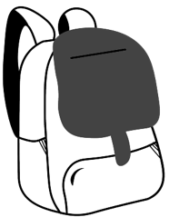 | - I bring work, books, pencils, or other tools to class when reminded.      pencil book      device paper  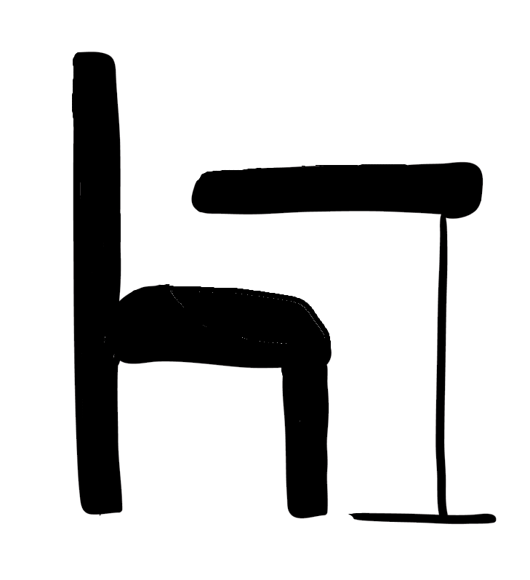  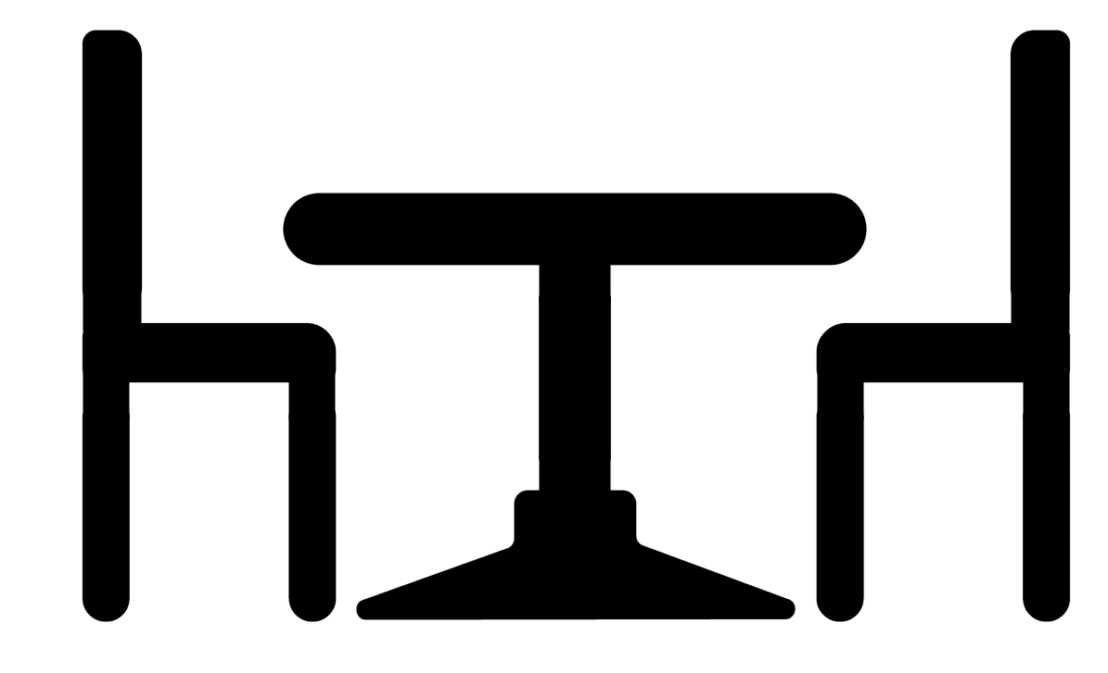  - My teacher tells me where to work and I go there.  desk table    carpet area | - I bring all the materials I need to learn.  pencil book  device paper  - I find an open place to work.  desk table  carpet area | all of Practicing plus  I help my classmates know how to get ready to learn.  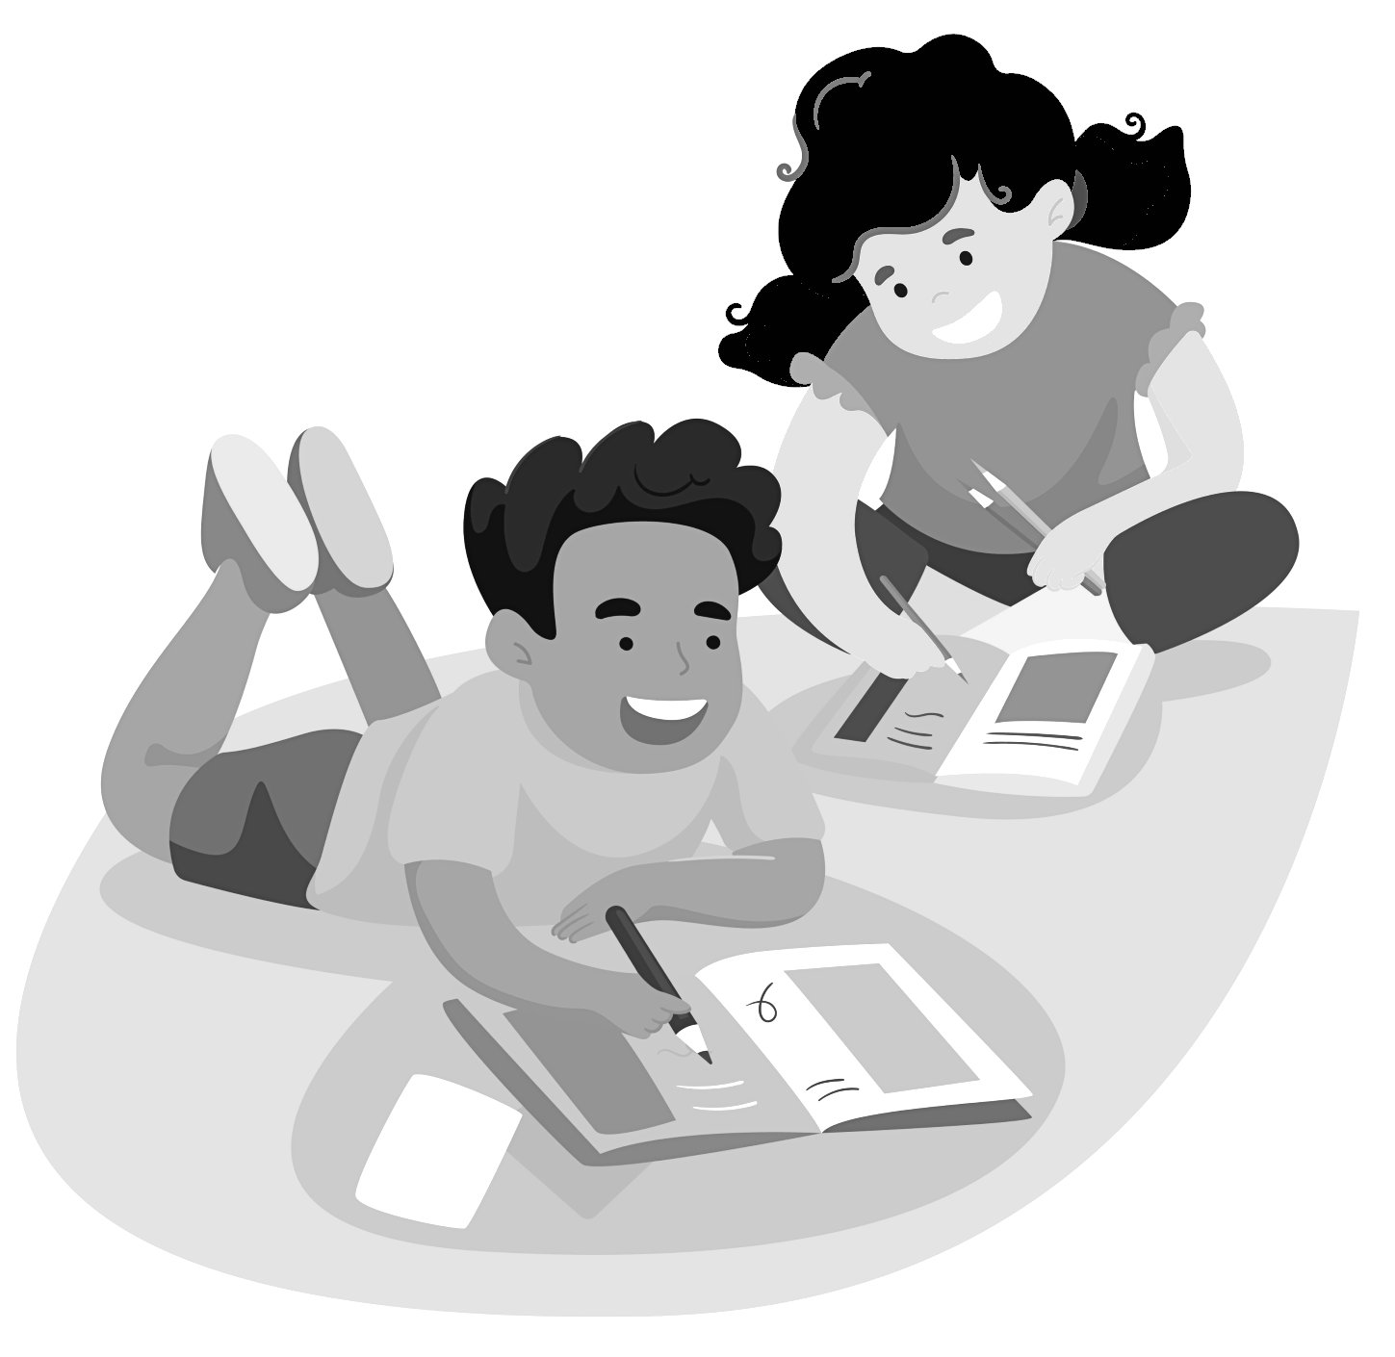
  I’m Responsible | 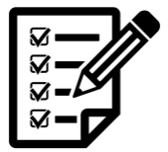  - I finish my work on time with reminders from my teacher.  - I keep my work in my folder.   | - I finish my work on time.  - I keep my completed work and work-in-progress in the correct pockets in my folder. | all of Practicing plus  When I finish early, I review my work and make it even better.  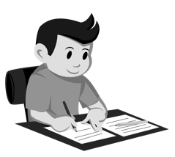

Page 2 of 3
 | Learning | Practicing | I Got It!
I Pay Attention  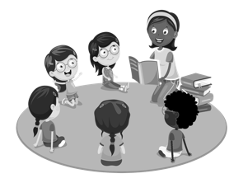 | - I stay on task by doing these things:  - I look with my eyes at the speaker.    - I listen with my ears to the speaker.    - If I get distracted, I get back on task with a reminder from my teacher or classmates. | - I stay on task by doing these things:  - I look with my eyes at the speaker.  - I listen with my ears to the speaker.  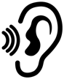    - I keep my body still while looking at and listening to the speaker.  - If I get distracted, I quickly get back on task. | all of Practicing plus  I take steps to help myself stay on task and ask for help when I can’t focus.  
I Work Well with Others   | 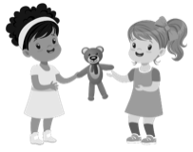  - I share things when asked.  - I share learning tools when asked.  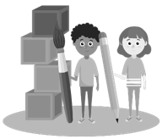  - I say “please” and “thank you.”  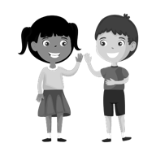 | - I offer to share things.  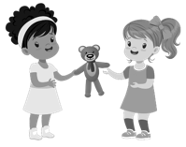  - I share learning tools and ideas.  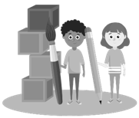  - I say “please” and “thank you” and use kind words.  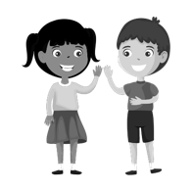 | all of Practicing plus  I help my classmates and my teacher when they need it.  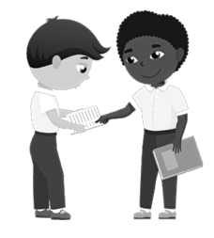

Page 3 of 3
 | Learning | Practicing | I Got It!
I Manage My Time  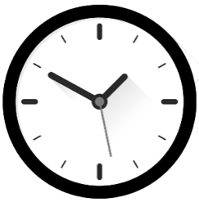 | 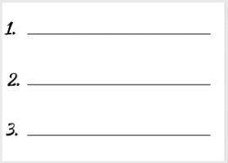  - I order my activities with help from a teacher.  - I follow my schedule with help from a teacher or classmate.  - I get to work when reminded by my teacher or classmates. | - I order my activities.  - I follow my schedule.  - I get to work right away. | all of Practicing plus  I help my classmates by explaining how I schedule my day.  