Student Material
Author’s Choice
Task Statement


What is your favorite book?

Who are the characters? What is the setting?

What if a writer set a book in our community? Wouldn’t that be fun? And what if some of the characters were you and your friends?

Authors get ideas for their writing in lots of ways. Let’s get in touch with our favorite authors. We can share our idea to write about our community. Maybe we’ll get to star in a published story!

Author’s Choice Rubric
Student Material
 | I Am Working on It!   | I Did It!   | I Did It and . . .  
Book Research   | I named the main character of my favorite story.  I named the setting of my favorite story. | I described the main character of my favorite story.  - I did it!  I described the setting of my favorite story.  - I did it!  I retold the big events of my favorite story.  - I did it! | I made up a different ending to my favorite story.
Letter Format   | My letter has a greeting.  My letter has a body.  My letter has a closing. | My letter has a formal greeting.  - I did it!  My letter has a body with at least three sentences.  - I did it!  My letter has a formal closing.  - I did it! | My letter includes the date.
 | I Am Working on It! | I Did It! | I Did It and . . .
Letter Content   | My letter has one sentence naming our community.  My letter has one sentence about a character. | My letter has one sentence naming our community, city, and state.  - I did it!  My letter has one sentence about a character.  - I did it!  My letter has one sentence about what the character could do.  - I did it! | I added a map of our community.
Letter  Mechanics and Spelling  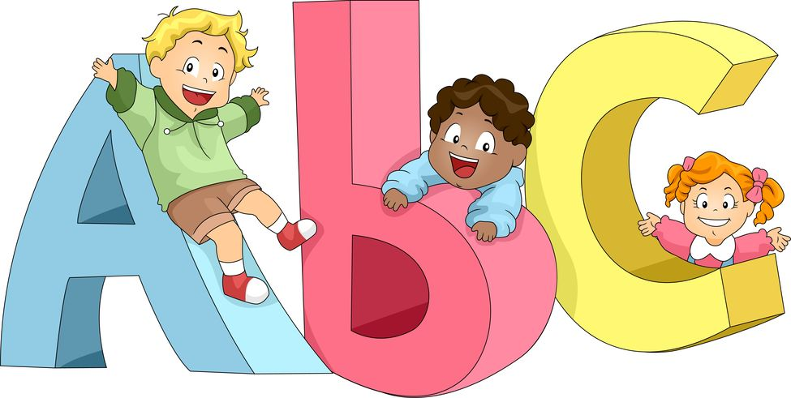 | I capitalized the first word of each sentence.  I used ending punctuation for each sentence. | I capitalized names and the first word of each sentence.  - I did it!  I used ending punctuation for each sentence.  - I did it!  I used the CVC spelling pattern.  - I did it! | I used commas in the greeting and closing.

Author’s Choice Scaffold for Learning
Teacher Material
Benchmark Video and Discussions
- Capital and lowercase
- Sounds and letters
- What is a character?
Instructional Activities: Learning
Instructional Activities: Additional
Instructional Texts/Websites  - Format a letter (I, P)  - Read and write CVC words (I)  - Write capital/lowercase letters  - Recognizing letters (I, P)  - CVC spelling patterns (I, P)  - Character study (I, P)  - Setting analysis (I, P)  - Big events (P, SG)  - Write an intro/body/closing (I)  - State, city, community study (I)  - Punctuation (I, P) | Instructional Videos  - Format a letter (I, P)  - Read and write CVC words (I)  - Write capital/lowercase letters  - Recognizing letters (I, P)  - CVC spelling patterns (I, P)  - Character study (I, P)  - Setting analysis (I, P)  - Big events (P, SG)  - Write an intro/body/closing (I)  - State, city, community study (I)  - Punctuation (I, P) | How-to Sheets  - Write capital letters  - Write lowercase letters  - Punctuation  - CVC spelling patterns  - Character analysis  - Setting study  - Identify big events | Practice  - Identify capital and lowercase letters (I)  - Identify CVC words (I)  - Order story events (IV)  - Retell stories (I, P)  - Identify/describe characters (I, P)
Application
- Use/blend/segment CVC patterns (I, P)
- Match capital and lowercase letters (I, P)
- Match beginning sound and letters (I, P)
- (Re)read books by favorite author (I)
- Sketch picture of community (IV)
- Find words with capital letters (I, P)
Interactive Websites  - Listen to audiobooks (I, P)  - Watch/listen to phonics songs (I)  - Watch/listen to phonemic awareness songs (I, P)  - CVC spelling games (P)  - Capital/lowercase match (I, P)  - Beginning sound match (HW) | Learning Centers  - Identify capital/lowercase letters (I, P)  - Match capital/lowercase letters (I, P)  - Match beginning sound/letters (I, P)  - Identify CVC words (I, P)  - Retell stories (P, SG, IV)  - Letter writing (I, P)  - Punctuation (I, P)  - Character/setting/big events (I) | Small-Group Mini-Lessons  - Format a letter  - Read and write CVC words  - Write capital/lowercase letters  - Recognizing letters  - CVC spelling patterns  - Character study  - Setting analysis  - Big events  - Write an intro/body/closing  - State, city, community study  - Punctuation | Assessment  - Assess capital and lowercase letters (I, P)  - Assess beginning sound and letters (I, P)  - Assess CVC words (I, P)  - Use rubric to assess retell stories (I, P)  - Use rubric to peer assess letter (I, P)  - Use rubric to self-assess letter (I)
Reflection
- Discuss strongest arguments for setting of our community (SG)
- What stories have you read that could easily use our community as a setting? (I)
- What did you like about this task? (I)
- What was challenging for you? (I)
Key: Individual (I), Pairs (P), Small Groups (SG), Activities suitable for homework (HW), Insights Video (IV)

Author’s Choice Content Facilitation Grid (Week 1 Sample)
Teacher Material
Student | Identifies capital letters. | Identifies lowercase letters. | Writes capital letters. | Writes lowercase letters. | Matches uppercase and lowercase letters. | Blends CVC words. | Segments CVC words. | Matches consonant sounds to letters. | Matches vowel sounds to letters. | Names characters in a story. | Describes physical traits of character. | Describes personality of character. | Orders story events. | Retells beginning of story. | Retells middle of story. | Retells end of story.

Author’s Choice Facilitation Questions
Teacher Material

COMPREHENSION:  Ask questions that ensure students understand content and skills needed to solve the problem. | - What is a setting?  - What is a character?  - What are the parts of a letter?  - What is a consonant?  - What is a vowel?  - What is blending?  - What is segmenting?
APPLICATION:  Ask questions that ensure the ability of students to apply learning to new situations. | - Who are the characters in this story?  - What is the setting of this story?  - Retell this story.  - When do you use capital letters?  - When do you use lowercase letters?  - Blend _______.  - Segment _______.
CONNECTION:  Ask questions that ensure the ability of students to apply learning to their lives. | - Which author is your favorite?  - When would you write a letter to someone?  - Why is it important for you to know the difference between capital and lowercase letters?  - How many capital letters are in your name? Lowercase? Consonants? Vowels?
SYNTHESIS:  Ask questions that encourage students to create new information from existing data. | - What can you learn about a character from the pictures in a story?  - What can you learn about a character from the author’s words?  - How would your favorite story change if the author changed the setting?
METACOGNITION: Ask questions that prompt students to think about their own thinking process. | - Which is easier for you — segmenting or blending words?  - What was the most difficult part of this task for you? Why?  - What did you like most about the task? Why?  - If you could make one change to your letter, what would it be?
Author’s Choice Differentiation Grid
Teacher Material

SKILL: Segmenting sounds in words

 | DISTAL ZONE  A student who will be challenged to learn this skill/concept or lacks the prerequisite skills needed. | PROXIMAL ZONE  A student who is ready to learn this or is on grade level. | CURRENT KNOWLEDGE  A student who is ready to move beyond this or is above grade level.
VISUAL | Use highlighters to color-code onsets and rhymes in a list of words. | Use highlighters to color-code onsets and rhymes in a story. | Use highlighters to color-code onset blends and rhymes in a story or poem.
AUDITORY | Listen to (and sing along with) a song focused on rhyming words. | Listen to (and sing along with) a song in which CVC words are segmented into onset and rhyme. | Listen to podcast or song in which the initial consonant sound of words is segmented and replaced with another.
KINESTHETIC/  TACTILE | Match pictures to initial consonant sounds. | Manipulate sentence strips with onsets and rhymes to create words found in a story. | Manipulate sentence strips with onsets and rhymes to create words. Sort words into two categories: real words and nonsense words.
* Readiness categories taken from Lev Vygotsky’s work on the Zone of Proximal Development.
Author’s Choice Performance Task
Student Material

It would be so exciting if your favorite author chose to set a story in our community!

Now that you have learned how to write a letter, let’s continue to use those skills.

What is something you would like to see or do here at school? Perhaps you can convince the teachers and administrators to make it happen!

Use your letter-writing skills to share an idea with our principal. When you write your letter, be sure to include the following:

  - A greeting
  - What you want to see or do
  - A closing
  - A labeled drawing of your idea

Author’s Choice Teacher Notes Guide
Teacher Material
Unit Overview
Wouldn’t it be special to see your community featured in a children’s book? Primary students learn the basics of story elements and letter writing to convince a favorite author to use their community as the setting for his/her next publication!
Common Core State Standards Addressed
CCSS.ELA-LITERACY.RL.K.1; CCSS.ELA-LITERACY.RL.1.1;
CCSS.ELA-LITERACY.RL.K.2; CCSS.ELA-LITERACY.RL.1.2;
CCSS.ELA-LITERACY.RL.K.3; CCSS.ELA-LITERACY.RL.1.3;
CCSS.ELA-LITERACY.W.k.1; CCSS.ELA-LITERACY.W.1.1;
CCSS.ELA-LITERACY.W.k.8; CCSS.ELA-LITERACY.W.1.8;
CCSS.ELA-LITERACY.rf.k.1; CCSS.ELA-LITERACY.rf.1.1;
CCSS.ELA-LITERACY.rf.k.2; CCSS.ELA-LITERACY.rf.1.2;
CCSS.ELA-LITERACY.rf.k.3; CCSS.ELA-LITERACY.rf.1.3;
CCSS.ELA-LITERACY.L.K.1; CCSS.ELA-LITERACY.L.1.1;
CCSS.ELA-LITERACY.L.K.2; CCSS.ELA-LITERACY.L.1.2
National Standards Addressed
NSS-G.K-12.1; NSS-G.K-12.2
Enduring Understandings | Essential Questions
- Writing is a powerful tool for communicating.  - Sharing ideas may inspire others.  - Stories have common characteristics (e.g., setting, characters, plot, etc.).  - Blending and segmenting sounds are stepping-stones for reading and writing. | - What are the elements of a story?  - How can we communicate our ideas through writing?  - Why is it important to use capital and lowercase letters correctly?
21st Century Skills Addressed
Core Content and Interdisciplinary Themes  - Subject-Area Mastery  - Global Awareness  Learning and Innovation  - Critical Thinking and Problem Solving  - Creativity and Innovation  - Communication and Collaboration | Information and Media Literacy  - Media Literacy  - Information and Communication Technology  Life and Career  - Flexibility and Adaptability  - Initiative and Self-Direction  - Productivity and Accountability

