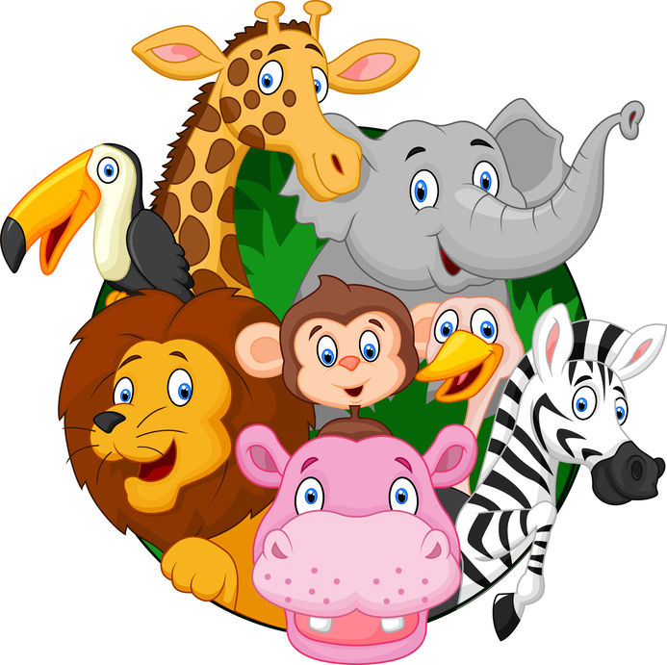
Virtual Visit to the Zoo
Student Material

Have you ever been to a zoo? Most large cities have zoos where people can see animals that normally live in the wild.
But what if you don’t live near a zoo? What if it is too expensive to go to the zoo?
What if we created a virtual zoo for kids who may not be able to visit a real zoo? We could share information about wild animals and their habitats. Think about which animals we should include in our virtual zoo and how to learn more about them.
Let’s work together so that all children have the chance to visit the zoo!

Virtual Visit to the Zoo Analytic Rubric
Student Material
 | Novice | Apprentice | Practitioner | Expert
Animal Research Log  Types of Animals | I named one example of each type of animal: mammal, bird, reptile, and amphibian. | - I named one example of each type of animal: mammal, bird, reptile, and amphibian.  - I listed two characteristics for each type of animal. | - I named one example of each type of animal: mammal, bird, reptile, and amphibian.  - I compared and contrasted two or more characteristics for each animal type. | I did all of Practitioner and  I classified each animal as a vertebrate or non-vertebrate and warm-blooded or cold-blooded.
Animal Research Log  Shared Habitats | I described each animal’s habitat with two or more characteristics. | - I described each animal’s habitat with three or more characteristics.  - I named two or more plants that live in each habitat. | - I described each animal’s habitat with three or more characteristics.  - I named two or more plants that live in each habitat.  - I named two or more other animals that share their habitat with my animal. | I did all of Practitioner and I classified the additional animals as mammal, bird, reptile, or amphibian.
Animal Research Log  Habitat Give and Take | I described one reason why each animal needs its specific habitat. | - I described how each animal gets food from its habitat.  - I described how each animal gives back to its habitat. (In other words, how does the animal help the plants and other animals in the habitat?) | - I described how each animal gets food and shelter from its habitat.  - I described how each animal gives back to its habitat. (In other words, how does the animal help the plants and other animals in the habitat?)  - I compared and contrasted two or more habitats. | I did all of Practitioner and I created a hypothesis of what might happen if two of my animals switched habitats.
Home Group  Script | Our home group collaborated to write:  - an introduction to our zoo  - two or more facts about each type of animal  - an example of each animal  - a conclusion | Our home group collaborated to write:  - an introduction to our zoo, including its name  - three or more facts about each type of animal  - an example of each animal  - a conclusion  - in complete sentences | Our home group collaborated to write:  - an introduction to our zoo, including its name  - three or more facts about each type of animal  - two or more sentences comparing animals within the same group  - an example of each animal  - a conclusion  - in complete sentences | I did all of Practitioner and our home group added dialogue between members.
Home Group  Virtual Exhibit | Our home group created a digital presentation that included:  - one photograph of each animal  - narration based on script | Our home group created a digital presentation that included:  - one photograph of each animal within its habitat  - narration based on script | Our home group created a digital presentation that included:  - one photograph or video of each animal within its habitat  - narration based on script | I did all of Practitioner and our home group added visual effects.
Student Material

Virtual Visit to the Zoo Scaffold for Learning
Teacher Material
Benchmark Video and Discussions
- Animals and their habitats
- Comparing main topics
Instructional Activities: Learning
Instructional Activities: Additional
Instructional Texts  - Learn about animals (birds, reptiles, fish, and amphibians)  - Learn about habitats | Instructional Videos  - Determine main topic  - Comparing main topics  - How to use the CVCe spelling pattern  - Classifying animals | How-to Sheets  - Using the CVCe spelling pattern  - Classifying animals  - Make a Venn diagram | Practice  - Gather photographs of animals (I, P, HW)  - Draw/label animal (I, P)  - Read CVCe words (I, P, HW)
Application
- Compare/Contrast texts – characteristics of animals (SG)
- Describe animals (P, SG)
- Spell CVCe words (I, P)
Interactive Websites  - “Match animals and their habitats”  - “Sort long vowels”  - “Make new words” | Learning Centers  - Categorize animals: birds and mammals  - Categorize animals: reptiles and amphibians  - Match animals and their habitats  - Determine main topic  - Word sort: long vowel sounds | Small-Group Mini-Lessons  - Determine main topic  - Compare texts  - Contrast texts  - Spelling CVCe words | Assessment  - Rubric Self-Assessment (I)  - Compare/contrast new text (SG, P)  - Categorize new animals (SG, P)
Reflection
- What was challenging about this unit?
- Why is it important to understand animals and their habitats?
Key: Individual (I), Pairs (P), Small Groups (SG), Activities suitable for homework (HW), Insights Video (IV)

Virtual Visit to the Zoo Facilitation Grid (Week 1 Sample)
 | Science Content |  |  |  |  |  |  |  |  | ELA Content
Student | Names one example of a bird | Names one example of a mammal | Names one example of a reptile | Names one example of a fish | Names one example of an amphibian | Defines habitat | Identifies at least two plants in each animal's habitat | Explains one reason animals need their habitat | Identifies one way animals help their habitat | Identifies main topic | Identifies similarities in illustrations of two texts | Identifies differences in illustrations of two texts | Identifies similarities between two main topics | Identifies differences between two main topics | Differentiates long and short vowel sounds | Creates CVCe words from CVC words

Virtual Visit to the Zoo Facilitation Questions
Teacher Material
Teacher Material
COMPREHENSION  Ask questions that ensure students understand content and skills needed to solve the problem. | - What is one characteristic of a mammal (bird, reptile, fish, amphibian, etc.)?  - What is a habitat?  - What is a main topic?  - What are the long vowel sounds?  - What makes a complete sentence?
APPLICATION  Ask questions that ensure the ability of students to apply learning to new situations. | - How are mammals and birds the same? How are they different?  - What is one way an animal can help its habitat?  - Why might some books about the same thing have different information?  - How can you make new words by changing the long vowel?
CONNECTION  Ask questions that ensure the ability of students to apply learning to their lives. | - What wild animals have you seen?  - What animal category do humans belong to? How can you tell?  - What type of animals would you like to see in a zoo?
SYNTHESIS  Ask questions that encourage students to create new information from existing data. | - How would an animal be affected if it were put in a different habitat?  - What can you learn by reading multiple texts on one topic?  - What new words can you make by changing CVC words to CVCe words?
METACOGNITION  Ask questions that prompt students to think about their own thinking process. | - How would you describe your home group’s ability to work together?  - If you had to select a habitat to live in, which would it be and why?  - What was the most difficult part of this task?

Virtual Visit to the Zoo Transfer Task
Student Material

An insectarium is like a zoo for insects! What insect would you feature in your insectarium?
Select from a ladybug, bumble bee, or an ant.
Read the text provided and create an informational poster about your insect.
Be sure to include the following:
- Name of animal
- Where it lives and what it eats
- Labeled illustration of the insect
- Four sentences describing the insect
Virtual Visit to the Zoo Teacher Notes Guide
Teacher Material
Unit Overview
The zoo is a great place to visit to learn about and appreciate wild animals. Unfortunately, not everyone is able to visit the zoo. Some people may live far away from the zoo; others may not have the financial ability to visit the zoo. Primary students are challenged with providing a virtual zoo experience for those who cannot visit a zoo themselves. In the process, students learn about animal life cycles, classification, and habitats.
Common Core State Standards Addressed
CCSS-LITERACY.RI.2.1; CCSS-LITERACY.RI.2.2; CCSS-LITERACY.RI.2.6;
CCSS-LITERACY.RI.2.7; CCSS-LITERACY.RI.2.9
CCSS-LITERACY.RF.2.3a
CCSS-LITERACY.W.2.2; CCSS-LITERACY.W.2.6; CCSS-LITERACY.2.K.7
CCSS-LITERACY.SL.2.4
Other National Standards Addressed
2-LS2-2; 2LS4-1
Enduring Understandings | Essential Questions
- Animals need certain things in order to survive.  - Animals use resources in their habitats and play a role in keeping the habitat healthy.  - Animals live in a variety of habitats.  - Multiple sources of information contribute to well-rounded research. | - What do animals need to survive?  - How do animals contribute to their habitats?  - Why is it important to gather research from multiple sources?
21st Century Skills Addressed
Core Content and Interdisciplinary Themes  - Subject-Area Mastery  - Environmental Literacy  Learning and Innovation  - Creativity and Innovation  - Communication and Collaboration | Information and Media Literacy  - Information Literacy  - Information and Communication Technology  Life and Career  - Initiative and Self-Direction  - Social and Cross-Cultural Skills  - Productivity and Accountability

