Turning Our School Green
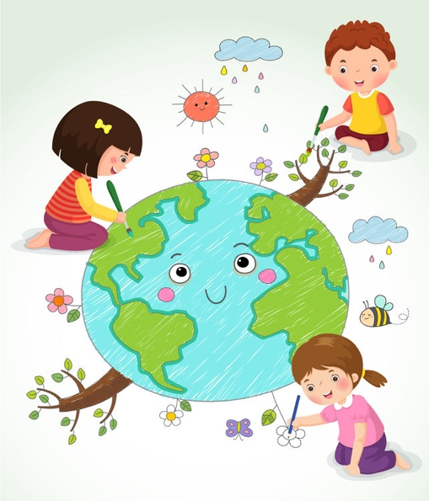
April 22 is Earth Day. Each year, people all over the world celebrate our Earth.

One way to celebrate our Earth is to learn how to take care of it.

We need water and energy from the Earth to live, but those resources could run out.

We need to help protect our resources so there will be enough for the future.

Have you heard of “going green”?

“Going green” means doing small things to help save the Earth’s resources.

What can we do at school to protect Earth’s resources? Let’s make a plan to turn our school green!

Turning Our School Green Rubric
 | I Am Working on It   | I Did It!   | I Did It and . . .  
Earth’s Resources  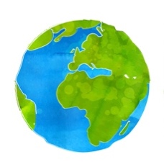 | I named one nonliving resource.  I named one living resource. | I named one nonliving resource and how people use it.  - I did it!  I named one living resource and how people use it.  - I did it! | I named something people could use instead!
Living Things  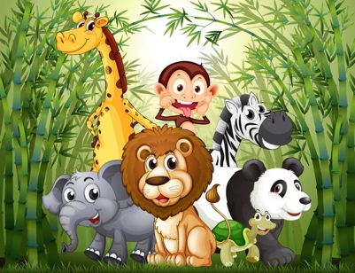 | I named three things all living things need. | I named three things all living things need.  - I did it!  I wrote one way plant needs and animals needs are different.  - I did it! | I made a chart of how human needs are the same as and different from plant needs.
Turning Our School Green Rubric continued
 | I Am Working on It | I Did It! | I Did It and . . .  
Habitats   | I drew the habitat of one animal.  I labeled one natural resource in the habitat. | I drew the habitat of one animal and labeled one natural resource in the habitat.  - I did it!  I wrote about how the habitat would change without the natural resource.  - I did it! | I made a cause-and-effect chain of what would happen to the animal if the natural resource was gone.
Going Green   | I drew and labeled a picture showing one way my school can be green. | I drew and labeled a picture showing two ways my school can be green.  - I did it!  I wrote two sentences to go with my drawing.  - I did it! | I wrote a sentence about how to be green at home and shared it with a grownup.
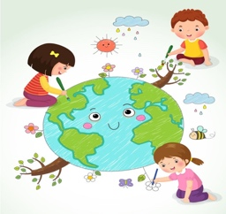
Turning Our School Green Scaffold for Learning
Benchmark Video and Discussions
- Launch
- Living and Nonliving
- What’s a Resource?
Instructional Activities: Learning

Instructional Activities: Additional
Instructional Texts  - Main topic of a text (HW)  - Key details of a text (P)  - Learn about living things (I, P)  - Learn about nonliving things (I, P)  - Learn about natural resources (I) | Instructional Videos  - Living and nonliving (P)  - Understand when to use capital letters (I, P)  - Identify key details of a text (IV)  - Learn about living things (HW)  - Learn about nonliving things (I, P)  - Learn about natural resources (I, P) | How-to Sheets  - Add punctuation to a sentence  - Login to the computer  - Use the word wall  - Identify living and nonliving things  - Clap out syllables  - Draw and label a picture | Practice  - Identify the main topic of a text (HW)  - Identify key details of a text (I)  - Compare and contrast living and nonliving things (P)
Application
- Observe animals and plants (P)
- Compare water sources of animals and plants (I, P)
- Animal habitat, details, and drawing (I, P)
- Animal writing (HW)
Interactive Websites  - Green Games  - Reading animal texts  - PBS Kids  - Starfall  - ReadWorks  - Khan Academy Kids  - IXL | Learning Centers  - Recycle Sort (P)  - Living and Nonliving (P)  - Identify the resource (SG)  - Understand when to use capital letters (P)  - Sort main topic and key details (I)  - Match beginning sounds (SG) | Small-Group Mini-Lessons  - What’s This Book About?  - Parts of a Book  - Sentence Builders  - Finding Main Idea  - Who, What, Where | Assessment  - Use rubric to self-assess (I)  - Self-assess punctuation (I)  - Self-assess sentence structure (I)
Reflection
- Learning exit ticket
- Two stars and a wish
- Complete: Something that I thought was tricky today was . . .
Key: Individual (I), Pairs (P), Small Groups (SG), Activities suitable for homework (HW), Insights Video (IV)

Turning Our School Green Content Grid
 | ELA Content |  |  |  |  |  |  |  |  | Science Content
Student | Identifies capital and lowercase letters | Uses correct capital and lowercase letters in writing | Uses ending punctuation | Uses one-to-one correspondence in reading | Identifies beginning sounds | Matches words with same beginning sounds | Applies CVC spelling pattern | Identifies the main idea of a text | Retells key details of a text | Identifies living things | Identifies nonliving things | Names differences between living and nonliving things | Defines natural resource | Names one natural resource that is living | Names one natural resource that is nonliving

Turning Our School Green Facilitation Questions

COMPREHENSION:  Ask questions that ensure students understand content and skills needed to solve the problem. | - What is a natural resource?  - What is a living thing?  - What is a nonliving thing?  - What do all living things need to survive?  - What is a habitat?
APPLICATION:  Ask questions that ensure the ability of students to apply learning to new situations. | - Why do we need natural resources?  - How are animals and plants alike?  - How are animals and plants different?  - How do you know if a detail is a key detail?  - When should you use a capital letter?
CONNECTION:  Ask questions that ensure the ability of students to apply learning to their lives. | - Which natural resources do you use every day?  - How could you reduce the natural resources you use?  - How are you like a plant?
SYNTHESIS:  Ask questions that encourage students to create new information from existing data. | - What would happen if we ran out of usable water?  - What would happen if we cut down all the trees to make paper?  - What would an animal do if its habitat were destroyed?
METACOGNITION:  Ask questions that prompt students to think about their own thinking process. | - Which natural resource do you think is the most important and why?  - What was the most difficult part of this task?  - What was the easiest part?  - What have you learned about our protecting our Earth?

Turning Our School Green Transfer Task
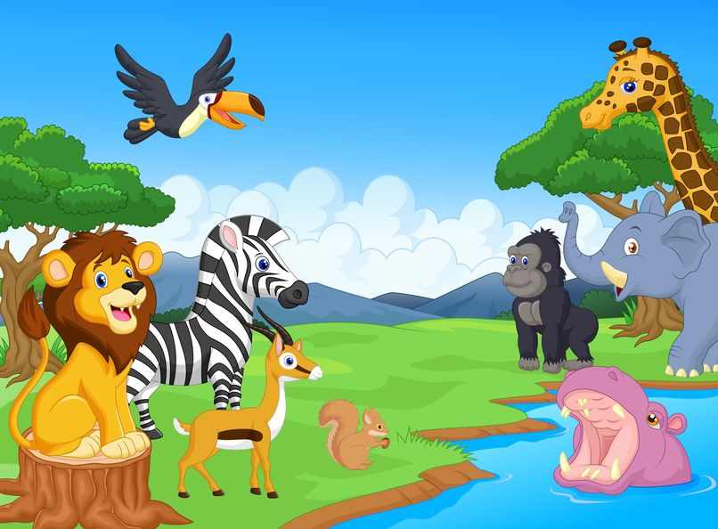
You have learned so much about living and nonliving things.
You have learned how we use Earth’s resources and how to conserve them.
Look at the picture below. Show what you have learned!
- Circle all the living things.
- Put an X on all the nonliving things.
- Name one animal in the picture: _______________________
- List three things the animal needs to survive:
  - _____________________________
  - _____________________________
  - _____________________________
- Name one natural resource in the picture: __________________________________
- Write one sentence about how to protect the natural resource:
___________________________________________________________________
___________________________________________________________________

Turning Our School Green Teacher Notes
Unit Overview
Protecting and conserving our Earth’s natural resources are activities in which anyone can participate, no matter how young! In this Authentic Learning Unit intended for primary grades, students will learn about living and nonliving things, habitats, and Earth’s natural resources. They will make connections to gain an understanding of how humans’ actions impact both the living and nonliving pieces of our Earth. They will explore ways to conserve natural resources and share their ideas with others to turn the school green!
Common Core State Standards Addressed
CCSS.ELA-LITERACY.RI.K.1; CCSS.ELA-LITERACY.RI.K.2; CCSS.ELA-LITERACY.RI.K.3;
CCSS.ELA-LITERACY.RI.K.5
CCSS.ELA-LITERACY.Rf.K.1; CCSS.ELA-LITERACY.Rf.K.2; CCSS.ELA-LITERACY.Rf.K.3
CCSS.ELA-LITERACY.W.K.2; CCSS.ELA-LITERACY.W.K.5
CCSS.ELA-LITERACY.l.K.1; CCSS.ELA-LITERACY.l.K.2

CCSS.ELA-LITERACY.RI.1.1; CCSS.ELA-LITERACY.RI.1.2; CCSS.ELA-LITERACY.RI.1.3;
CCSS.ELA-LITERACY.RI.1.5
CCSS.ELA-LITERACY.Rf.1.1; CCSS.ELA-LITERACY.Rf.1.2; CCSS.ELA-LITERACY.Rf.1.3
CCSS.ELA-LITERACY.W.1.2; CCSS.ELA-LITERACY.W.1.5
CCSS.ELA-LITERACY.l.1.1; CCSS.ELA-LITERACY.l.1.2
Other National Standards Addressed
K-LS1-1; K-ESS3-1; K-ESS3-3; K-2-ETS1-1; K-2-ETS1-2
NSS-EC.K-4.1
Enduring Understandings | Essential Questions
- The Earth has a limited amount of natural resources that must be conserved.  - Human decisions and activities have had a profound impact on the physical and living environments.  - Reducing, reusing, conserving, and recycling are important in protecting earth’s natural resources.  - Everyone can help preserve the Earth’s natural resources. | - Why is it important for each of us to take an active role in caring for our planet?  - What are helpful/harmful ways humans change the environment?  - How can we make our school “greener”?  - How can pictures help us read?  - How can I write to give others information?
21st Century Skills Addressed
Core Content and Interdisciplinary Themes  - Subject-Area Mastery  - Global Awareness  - Environmental Literacy  Learning and Innovation  - Critical Thinking and Problem Solving  - Creativity and Innovation  - Communication and Collaboration | Information and Media Literacy  - Information Literacy  - Media Literacy  Life and Career  - Flexibility and Adaptability  - Initiative and Self-Direction  - Productivity and Accountability  - Leadership and Responsibility

