A World Without Butterflies
Student Material

Task Statement

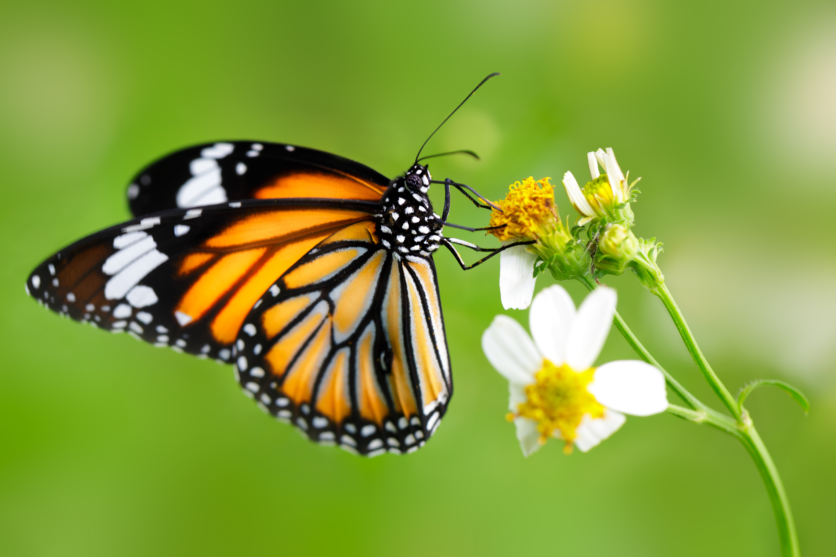
Butterflies are all over!

They are pretty. They come in lots of colors. It is fun to watch them fly!

There is a group called the Conservation for Butterflies Association. It says butterflies are in trouble. They are having a hard time living. Their habitats are in danger. They might be destroyed.

What if butterflies went extinct? They would be like the dinosaurs. How would our world change?

Groups like the Conservation for Butterflies Association need help. They want to tell people how to save the butterflies. Let’s work together. We will teach others about the beautiful butterflies!

A World Without Butterflies Rubric
Student Material

 | I Am Working on It   | I Did It!   | I Did It and . . .  
Butterfly Drawing   | I drew at least four butterfly body parts. | I drew at least four butterfly body parts.  - I did it!  I labeled all of the body parts in my drawing.  - I did it! | I made a chart of how each part is like or not like a human body part.
Butterfly Life Cycle   | I drew all four stages of the butterfly’s life cycle. | I drew all four stages of the butterfly’s life cycle.  - I did it!  I labeled all four stages of the butterfly’s life cycle.  - I did it! | I added details to each drawing of the butterfly’s life cycle to show the best habitat for each stage.

 | I Am Working on It | I Did It! | I Did It and . . .
Butterfly  Habitat   | I drew a picture of where butterflies live. | I drew a picture of where butterflies live.  - I did it!  I labeled at least four important parts of the butterfly’s habitat.  - I did it! | I made a chart of how each part of the butterfly’s habitat is like or not like a human’s habitat.
Butterfly Writing   | I wrote a sentence telling what butterflies need to live. | I wrote a sentence telling what butterflies need to live.  - I did it!  I wrote a sentence telling how humans can protect butterflies.  - I did it! | I wrote a sentence telling how butterflies help humans.

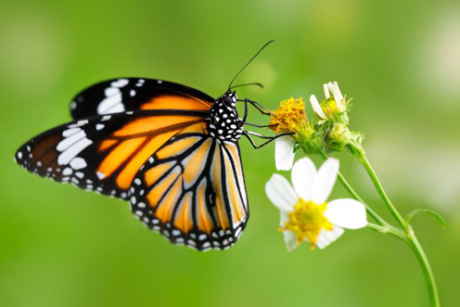
A World Without Butterflies Scaffold for Learning
Teacher Material
Benchmark Video and Discussions
- Unit launch to create felt need
- What is a butterfly?
- Understanding cycles
Instructional Activities: Learning
Instructional Activities: Additional
Instructional Texts/Websites  - Draw a butterfly  - Investigate butterfly habitats  - Sentence writing  - Identify text features  - Butterfly life cycles  - CVC words  - CVCe words  - Illustrations vs. photographs (IV) | Instructional Videos  - Draw a butterfly  - Investigate butterfly habitats  - Sentence writing  - Identify text features  - Butterfly life cycles  - CVC words  - CVCe words  - Illustrations vs. photographs (IV) | How-to Sheets  - Draw a butterfly  - Label drawings  - Spell CVC words  - Spell CVCe words  - Sentence structure  - Capital letter use | Practice  - Find text features (HW)  - Examine butterflies (HW)  - Research butterflies (I, P)  - Draw butterflies (I)  - Match CVC and CVCe words and pictures (I, P)
Application
- Research butterflies nationally and internationally (I, P)
- Label butterfly parts (I, P)
- Sort word families (I, P)
Interactive Websites  - Build a butterfly (I, P)  - Find the details  - Butterfly cycles  - National Geographic for Kids | Learning Centers  - Build a butterfly (P, SG)  - Life cycle of a butterfly  - Identify cycles (P)  - Compare/contrast CVC and CVCe words (I, P)  - Learn from pictures (IV)  - Identify text features (I, P) | Small-Group Mini-Lessons  - Draw a butterfly  - Investigate butterfly habitats  - Sentence writing  - Identify text features  - Butterfly life cycles  - CVC words  - CVCe words  - Illustrations vs. photographs | Assessment  - Using rubric, peer edit work (P)  - Self-assess butterfly life cycle (I)  - Self-assess CVC/CVCe (I)  - Capital letter use (I, P)
Reflection (I)
- In your Efficacy Notebook, reflect on this task. Ask yourself: What surprised you about butterflies? What might you do to help butterflies? What other insect is similar to a butterfly? How is it similar?

Key: Individual (I), Pairs (P), Small Groups (SG), Activities suitable for homework (HW), Insights Video (IV)

A World Without Butterflies Content Facilitation Grid (Week 1 Sample)
Teacher Material

Student | Draws a butterfly accurately | Labels drawings appropriately | Orders the stages of the life cycle of a butterfly | Identifies the stages of the life cycle of a butterfly | Names other types of cycles | Names components of the habitat of a butterfly | Identifies circular stories | Retells circular stories | Segments CVC words | Segments CVCe words | Blends CVC words | Blends CVCe words | Applies CVC spelling pattern | Applies CVCe spelling pattern | Differentiates photographs from illustrations | Gathers information from photographs | Identifies photographs/illustrations in text

COMPREHENSION  Ask questions that ensure students understand content and skills needed to solve the problem. | - What are the four stages of the butterfly life cycle?  - What are the body parts of a butterfly?  - What does extinction mean?  - Where do butterflies live?  - What is one thing butterflies need to survive?
APPLICATION  Ask questions that ensure the ability of students to apply learning to new situations. | - Which body parts of a butterfly are similar to a person’s body parts?  - How is a butterfly’s body different from a person’s?  - Why is it important to save the butterflies?  - Why do we label our drawings and diagrams?  - How is a butterfly dependent on its habitat?
CONNECTION  Ask questions that ensure the ability of students to apply learning to their lives. | - How are butterflies helpful to our environment/community?  - How is a human’s life cycle similar to the life cycle of a butterfly? How are they different?  - What are the basic needs of all living things?  - When do we use maps and why?
SYNTHESIS  Ask questions that encourage students to create new information from existing data. | - How would the extinction of butterflies impact our environment?  - When is it important to follow a sequence and why?  - How can you use your knowledge about life cycles and apply it to other living things?  - What do you think is the most important part of the butterfly’s life cycle and why do you think that?
METACOGNITION  Ask questions that prompt students to think about their own thinking process. | - How has this unit helped you understand the importance of butterflies?  - What was the best part about this unit?  - What new information have you gained about other living things through this unit?  - What was the most challenging aspect of this unit?

A World Without Butterflies Content Facilitation Questions
Teacher Material

A World Without Butterflies Transfer Task
Student Material

Did you know that another common animal is in danger of becoming extinct? Some kinds of frogs are having a hard time surviving, just like some butterflies. In the past 50 years, more than 200 types of frogs have gone extinct!

Can you help them the same way you helped the butterflies?

- Read about the life cycle of a frog.
- Learn what they need to live.
- Write one sentence telling what frogs need to live.
- Write one sentence telling how humans can help frogs.

Teacher Material
Unit Overview
Students will learn about butterflies — their life cycle and why they are important — as they write to inform others how to protect these special creatures. In addition to learning about the life cycle of a butterfly, students gain an understanding of how to read and interpret informational texts.
Common Core Standards Addressed
CCSS.ELA-Literacy.RI.1K.1; CCSS.ELA-Literacy.RI.1.1; CCSS.ELA-Literacy.RI.K.2;
CCSS.ELA-Literacy.RI.1.2; CCSS.ELA-Literacy.RI.K.3; CCSS.ELA-Literacy.RI.1.3;
CCSS.ELA-Literacy.RI.K.4; CCSS.ELA-Literacy.RI.1.4; CCSS.ELA-Literacy.RI.K.5;
CCSS.ELA-Literacy.RI.1.5; CCSS.ELA-Literacy.RI.K.6; CCSS.ELA-Literacy.RI.1.6;
CCSS.ELA-Literacy.RI.K.7; CCSS.ELA-Literacy.RI.1.7
CCSS.ELA-Literacy.RF.K.1; CCSS.ELA-Literacy.RF.1.1; CCSS.ELA-Literacy.RF.K.2;
CCSS.ELA-Literacy.RF.1.2; CCSS.ELA-Literacy.RF.K.3; CCSS.ELA-Literacy.RF.1.3
CCSS.ELA-Literacy.W.K.2; CCSS.ELA-Literacy.W.1.2
CCSS.ELA-Literacy.L.K.1; CCSS.ELA-Literacy.L.1.1; CCSS.ELA-Literacy.L.K.2;
CCSS.ELA-Literacy.L.1.2

Other National Standards Addressed
Next Generation Science Standards
K-LS1-1; K-ESS3-1; K-ESS3-3
1-LS1-2; 1-LS3-1

Enduring Understandings | Essential Questions
- Living things need air, food, and water.  - Living things grow and change.  - Living things have life cycles.  - Changes within ecosystems may affect organisms and their adaptations for survival | - What changes do living things go through during their lives?  - What are the stages of the butterfly life cycle?  - How do living things affect their environment and how do changes in the environment affect living things?  - What do all animals need to survive?
21st Century Skills Addressed
Core Content and Interdisciplinary Themes  - Subject-Area Mastery  - Environmental Literacy  Learning and Innovation  - Creativity and Innovation  - Communication and Collaboration | Information and Media Literacy  - Information Literacy  - Media Literacy  Life and Career  - Flexibility and adaptability  - Productivity and Accountability  - Leadership and Responsibility
A World Without Butterflies Teacher Notes

