Extreme Weather: Are You Prepared?
Student Material
Task Statement

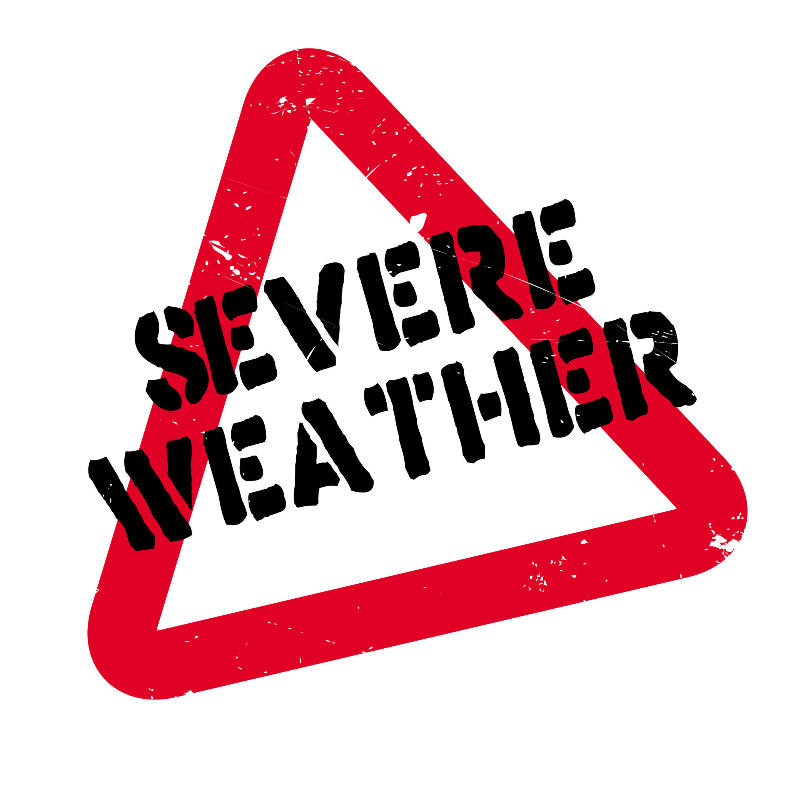
How much do you know about severe weather and how to stay safe?

Did you know the Earth has earthquakes every day? In fact, earthquakes are very common. There are even websites that track daily seismic events. Most happen in the ocean or are too small to be felt. The most powerful measured earthquake was a 9.5 on the Richter scale. It occurred in Chile in 1960. It caused a tsunami that killed nearly 6,000 people. Earthquakes are hard to prepare for. They are unpredictable.

Hurricanes are a bit more predictable. They are also a little less common than earthquakes. But they can still cause disasters. One of the worst hurricanes in history was 2005’s Hurricane Katrina. It caused over $161 billion in damages.

Many people associate hurricanes with Florida. But they are common in Texas and Louisiana, too. They also happen in the northeastern United States. You may think of California and Japan when you think of earthquakes. Would you be surprised to learn Ohio had a 4.0 magnitude earthquake in June 2019?! Or that over 9 feet of snow fell in California in February 2023?

Are you ready for strange weather? It can happen. For instance, there was a “snow spout” in New Mexico. That's basically a snow tornado! There was an extreme drought in Alaska. And there was snow in Hawaii!

What is our typical weather? What would be “atypical” for us? What happens if strange weather happens? How can we keep ourselves and our property safe?

Design a resource for families in our area. It will tell how to prepare for extreme weather. Give tips for how to stay safe. Offer suggestions for emergency kit items. Whatever weather we might get, we will be prepared!

Extreme Weather: Are You Prepared? Analytic Rubric (Individual Research Journal)
Student Material
 | Novice | Apprentice | Practitioner | Expert
Extreme Weather | identifies 1 hazard for each of the following:  - heavy rain  - heavy snow  - strong winds  - lightning  - flooding | describes 1 possible cause (e.g., type of extreme weather) and 1 hazardous effect for each of the following:  - heavy rain  - heavy snow  - strong winds  - lightning  - flooding | describes 2 or more possible causes (e.g., type of extreme weather) and hazardous effects for each of the following:  - heavy rain  - heavy snow  - strong winds  - lightning  - flooding | all of Practitioner plus: describes 2 or more real-life examples of extreme weather
Preparation | names 1 solution that minimizes impact of hazard for 1 type of extreme weather | names benefits and risks of hazards for 2 types of extreme weather | describes benefits and risks of hazards for 3 or more types of extreme weather | all of Practitioner plus: hypothesizes how solution can be improved upon
Atypical Weather | summarizes and synthesizes 2 news items on atypical weather using the following resources:  - video  - print  - local resource | summarizes and synthesizes 3 news items on atypical weather using 1 each of the following resources:  - video  - print  - local resource | summarizes and synthesizes 4 or more news items on atypical weather using 1 each of the following resources:  - video  - print  - local resource | all of Practitioner plus: compares and contrasts 1 typical and 1 atypical weather event for local area
Weather Map | maps of United States and world include:  - picture labeling common types of extreme weather in at least 2 areas  - picture labels identifying atypical extreme weather for at least 2 areas  - title and legend | maps of United States and world include 3 of the following:  - color-coding to show typical climates for each area studied  - picture labels illustrating common types of extreme weather in each area studied  - picture labels identifying atypical extreme weather for 5 or more areas studied  - title, legend, compass rose, and scale | maps of United States and world include:  - color-coding to show typical climates for each area studied  - picture labels illustrating common types of extreme weather in each area studied  - picture labels identifying atypical extreme weather for 5 or more areas studied  - title, legend, compass rose, and scale | all of Practitioner plus: highlights Earth’s features that influence climate and weather for at least 1 region

 | Novice | Apprentice | Practitioner | Expert
How to Prepare | includes:  - introduction of topic (e.g., preparing for extreme weather in our area)  - explanation of what to do to prepare for typical weather using 2 or more facts, details, etc.  - conclusion | includes:  - introduction of topic (e.g., preparing for extreme weather in our area)  - explanation of what to do to prepare for typical extreme weather using 2 or more facts, details, etc.  - explanation of what to do to prepare for 1 type of atypical extreme weather for our area using 2 or more facts, details, etc.  - conclusion section | includes:  - introduction of topic (e.g., preparing for extreme weather in our area)  - explanation of what to do to prepare for typical extreme weather using 3 or more facts, details, etc.  - explanation of what to do to prepare for 1 type of atypical extreme weather for our area using 3 or more facts, details, etc.  - linking words to connect ideas in each category (typical and atypical extreme weather)  - conclusion section | all of Practitioner plus: includes diagrams, illustrations, charts, or other text feature to support explanations
Emergency Kit Suggestions | - lists 4–6 items in order of priority  - description of how each item could be used in typical or atypical extreme weather situations | - lists 6–8 items in order of priority  - explanation of how each item is useful for typical or atypical extreme weather situations | - lists 8–10 items in order of priority  - explanation of how each item is useful for typical and atypical extreme weather situations | all of Practitioner plus: includes cost and/or shelf life of each item if applicable
Extreme Weather: Are You Prepared? Analytic Rubric (Group Kit and Tips)
Student Material

Extreme Weather Scaffold for Learning
Teacher Material

Benchmark Video and Discussions
- Unit Launch “Extreme Weather”
- All Kinds of Data
Instructional Activities: Learning
Instructional Activities: Additional
Instructional Texts/Websites  - Read graphs to describe weather patterns (I, P)  - Compare and contrast: sleet, hail, snow  - Compare and contrast: Hurricane, tornado, blizzard (IV)  - Determine main idea  - Summarize information (I, P)  - Read scaled graphs (I, P)  - Understand weather data  (I, P, SG)  - Create a preparation plan/kit  (I, P, SG, IV) | Instructional Videos  - Read graphs to describe weather patterns (I, P)  - Compare and contrast: sleet, hail, snow  - Compare and contrast: Hurricane, tornado, blizzard (IV)  - Determine main idea  - Summarize information (I, P)  - Read scaled graphs (I, P)  - Understand weather data  (I, P, SG)  - Create a preparation plan/kit  (I, P, SG, IV) | How-to Sheets  - Work in a group  - Conduct an internet search  - Read a bar graph  - Read a picture graph  - Read a data table  - Summarize information  - Determine main idea | Practice  - Label world map continents/water bodies  - Compare and contrast maps and globes  - Determine main idea (I)  - Watch/listen to weather reports (IV)  - Read/create bar graphs and tables (I, P)  - Access weather data (I)  - Describe weekend weather
Application
- Discussion protocol: reading graphs to describe weather patterns (P, SG)
- Compare and contrast effects of hurricanes and tornados (P, SG)
- Design a plan (I, P)
- Create a way to educate others (I, P, SG)
Interactive Websites  - Google Earth  - Weather Channel  - Make a Graph (I, P, SG)  - Freerice — weather | Learning Centers  - Describe weather patterns using graphs (I, P)  - Match: severe weather vocabulary, definitions, scenarios (I, P)  - Compare and contrast: sleet, hail, snow (I, P)  - Compare and contrast: hurricane, tornado, blizzard (I, P)  - Connect text features to main idea (I, P)  - Identify continents and bodies of water (I, P, SG) | Small-Group Mini-Lessons  - Read graphs to describe weather patterns  - Compare and contrast: sleet, hail, snow  - Compare and contrast: Hurricane, tornado, blizzard  - Determine main idea  - Summarize information  - Read scaled graphs  - Create a preparation plan/kit | Assessment  - Self-assess graph reading (I)  - Self-assess reading a data table (I)  - Self-assess traits of a hurricane, tornado, blizzard (I)  - Using rubric peer edit task (P)  - Using rubric self-assess task (I)
Reflection (I)
- Where would you like to live?
- Where would you prefer not to live?
- Are you interested in pursuing a career in weather? Why or why not?
- What did you like about this unit?
Key: Individual (I), Pairs (P), Small Groups (SG), Activities suitable for Homework (HW), Insights Video (IV)
Extreme Weather: Are You Prepared? Content Facilitation Grid (Week 1 Sample)
Teacher Material
 | Math |  |  |  | Science |  |  |  |  |  | Social Studies |  |  |  | ELA
Student | Categorizes weather data | Defines scaled graphs | Displays weather data on scaled picture graph | Displays weather data on scaled bar graph | Defines extreme/severe weather | Provides example of extreme/severe weather | Identifies severe weather that causes strong winds | Identifies hazards of strong winds | Identifies severe weather that causes heavy precipitation | Identifies hazards of heavy precipitation | Identifies globe | Identifies map | Differentiates globes and maps | Differentiates continents and oceans | Determines main idea of text | Connects text features to main idea | Identifies cause-and-effect relationships in texts

Extreme Weather: Are You Prepared? Facilitation Questions
Teacher Material

COMPREHENSION:  Ask questions that ensure students understand content and skills needed to solve the problem. | - What is a hurricane?  - What is a globe?  - What is one hazard of a thunderstorm?  - What solution limits house flooding?  - What is a bar graph?
APPLICATION:  Ask questions that ensure the ability of students to apply learning to new situations. | - How many more blizzards occurred in the United States compared to hurricanes (using data from a graph)?  - How do lightning rods reduce the chance of fires during extreme weather?  - What details support the main idea of this text?  - What facts did you use to describe atypical weather in our area?
CONNECTION:  Ask questions that ensure the ability of students to apply learning to their lives. | - What type of severe weather have you experienced?  - How did you prepare for severe weather in the past?  - What would you do differently to prepare for severe weather after this unit?
SYNTHESIS:  Ask questions that encourage students to create new information from existing data. | - What type of atypical weather could our area experience if we had an unseasonably cold summer? Winter?  - What type of atypical weather could our area experience if we had an unseasonably hot winter? Summer?
METACOGNITION: Ask questions that prompt students to think about their own thinking process. | - How would you evaluate your team’s ability to work together?  - What was the most difficult part of this task for you?  - How did you determine which type of weather to create your plan for?

Extreme Weather: Are You Prepared? Performance Task
Student Material

Suppose you were given the task of evaluating severe weather emergency kits for your school. Would the following kit pass your test, or do you need to add items to it? What would you add and why?

Basic Disaster Supplies Kit
To assemble your kit, store items in airtight plastic bags and put your entire disaster supplies kit in one or two easy-to-carry containers such as plastic bins or a duffel bag.

A basic emergency supply kit could include the following recommended items:
- Water (one gallon per person per day for several days, for drinking and sanitation)
- Food (at least a several-day supply of nonperishable food)
- Battery-powered or hand-crank radio and a NOAA weather radio with tone alert
- Flashlight
- First-aid kit
- Extra batteries
- Whistle (to signal for help)
- Dust mask (to help filter contaminated air)
- Plastic sheeting and duct tape (to shelter in place)
- Moist towelettes, garbage bags, and plastic ties (for personal sanitation)
- Wrench or pliers (to turn off utilities)
- Manual can opener (for food)
- Local maps
- Cell phone with chargers and a backup battery

Be sure to do the following:
- Name two or more needed items.
- Explain why each item is needed.

Extreme Weather: Are You Prepared? Teacher Notes
Teacher Material
Unit Overview
You may be prepared for the typical severe weather in your region, but what about weather that is out of the norm? In this Authentic Learning Unit, students research past atypical, extreme weather. As they learn about the hazards of such weather, they collaborate to create resources to support families in planning for possible extreme weather.
Common Core State Standards Addressed
CCSS.ELA-LITERACY.RI.3.1; CCSS.ELA-LITERACY.RI.3.3;
CCSS.ELA-LITERACY.RI.3.4; CCSS.ELA-LITERACY.RI.3.5;
CCSS.ELA-LITERACY.RI.3.7

CCSS.ELA-LITERACY.W.3.2; CCSS.ELA-LITERACY.W3.4;
CCSS.ELA-LITERACY.W.3.5; CCSS.ELA-LITERACY.W.3.7;
CCSS.ELA-LITERACY.W.3.8

CCSS.ELA-LITERACY.SL.3.2

CCSS.MATH.CONTENT.3.MD.B.3

Other National Standards Addressed
3-ESS2-1; 3-ESS2-2; 3-ESS3-1

NSS-G.K-12.1; NSS-G.K-12.2; NSS-G.K-12.3; NSS-G.K-12.6
Enduring Understandings | Essential Questions
- Weather is the result of short-term variations in temperature, humidity, and air pressure.  - Climate is the result of long-term patterns of temperature and precipitation.  - The world is made up of regions that differ in weather and land. | - What is severe weather?  - What hazards are associated with severe weather?  - What types of severe weather are more likely than others for our region?
21st Century Skills Addressed
Core Content and Interdisciplinary Themes  - Subject-Area Mastery  - Global Awareness  - Environmental Literacy | Information and Media Literacy  - Information Literacy  - Media Literacy  - Information and Communication Technology
Learning and Innovation  - Critical Thinking and Problem Solving  - Creativity and Innovation  - Communication and Collaboration | Life and Career  - Flexibility and Adaptability  - Initiative and Self-Direction  - Social and Cross-Cultural Skills  - Productivity and Accountability  - Leadership and Responsibility

